**LO: I can identify the meanings of my new words and write a sentence for each word.**

**1-Hatch:** 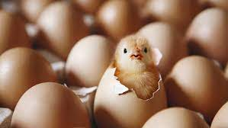

**____________________________________________**

**2-Quarrel:** 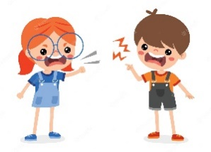

**3-Scruffy:** 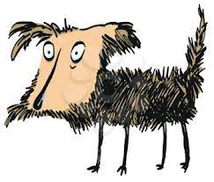

**4-feathers:** 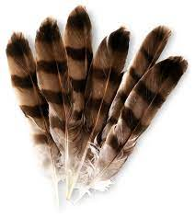

**___________________________________________________________**

**5-Gaze:** 

