Spelling Words Year 2 Term 1

|  |  |  |
| --- | --- | --- |
|  | Common words | Write a sentence for each word |
| 1 | **want** | My Sentence: |
| 2 | **where** | My Sentence: |
| 3 | **who** | My Sentence: |
| 4 | **why** | My Sentence: |
| 5 | **which** | My Sentence: |
| 6 | **noise** | My Sentence: |
| 7 | **voice** | My Sentence: |
| 8 | **before** | My Sentence: |
| 9 | **important** | My Sentence: |
| 10 | **because** | My Sentence: |

**Name:……………………………………. Date: ……………………………..**

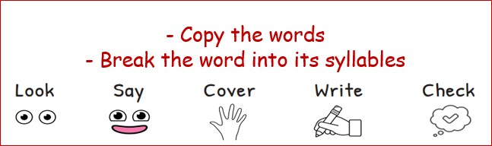

|  |  |  |  |  |
| --- | --- | --- | --- | --- |
| Sunday | Monday | Tuesday | Wednesday | Thursday |
|  |  |  |  |  |
|  |  |  |  |  |
|  |  |  |  |  |
|  |  |  |  |  |
|  |  |  |  |  |
|  |  |  |  |  |
|  |  |  |  |  |
|  |  |  |  |  |
|  |  |  |  |  |
|  |  |  |  |  |

Please practice your spelling words every day for your spelling exam on Sunday. Good luck! :)