**Year 7**

**Name:________________________ Date: ___________________**

**Persuasive Writing model**

**Read the following leaflet and point out the features of persuasive writing**

Are you ready for an unforgettable adventure? Look no further than Iceland, the land of fire and ice, where nature's wonders await you at every turn. Prepare to be mesmerized by stunning landscapes, exhilarating activities, and a culture rich in history and tradition. Here are just a few reasons why you should pack your bags and visit Iceland today:

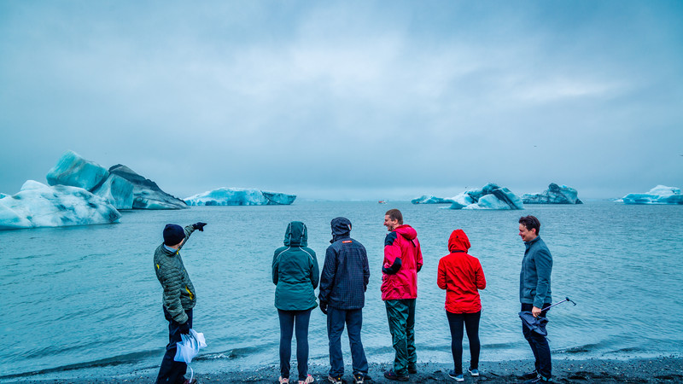**Spectacular Landscapes**: From cascading waterfalls and towering glaciers to volcanic landscapes and black sand beaches, Iceland boasts some of the most breathtaking scenery on Earth. Explore the iconic Golden Circle, marvel at the Northern Lights, or embark on a glacier hike for an experience you'll never forget.

**Thrilling Adventures**: For adrenaline junkies and nature enthusiasts alike, Iceland offers a myriad of thrilling activities. Dive between tectonic plates in crystal-clear waters, embark on a whale-watching excursion, or ride an Icelandic horse through scenic valleys. With options for every adventurer, Iceland promises excitement around every corner.

**Cultural Riches**: Immerse yourself in Iceland's rich cultural heritage by exploring charming villages, visiting historic landmarks, and indulging in local cuisine. Sample traditional Icelandic dishes like hearty lamb stew and fresh seafood, or unwind in one of the country's many geothermal pools for a truly authentic experience.

**Warm Hospitality**: Experience the warmth and hospitality of the Icelandic people, known for their friendliness and welcoming nature. Whether you're chatting with locals in a cozy café or joining in on a traditional Icelandic celebration, you'll feel right at home in this vibrant and inclusive community.

[Call to Action: Plan your Icelandic adventure today and embark on the journey of a lifetime! Visit our website or contact us for more information and to book your trip.]

[Footer: Your Icelandic adventure awaits! Don't miss out on the experience of a lifetime. Visit Iceland today!]