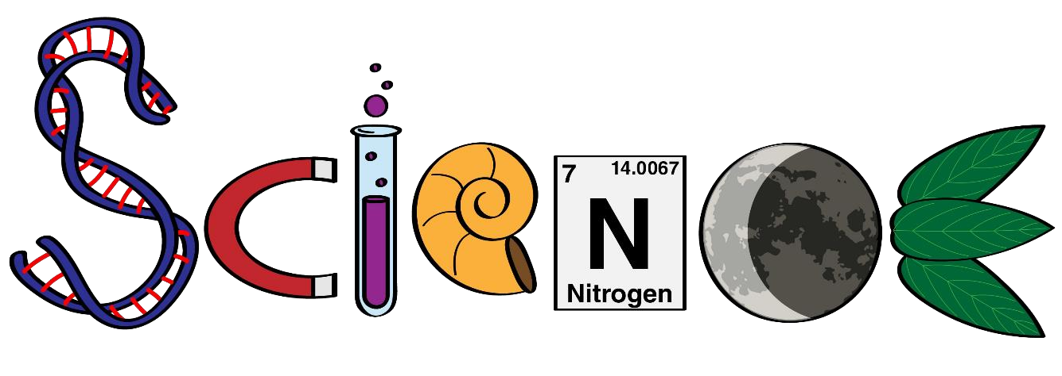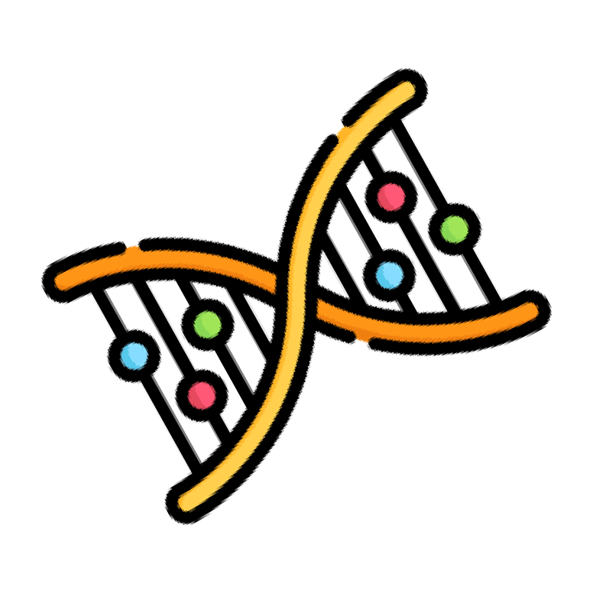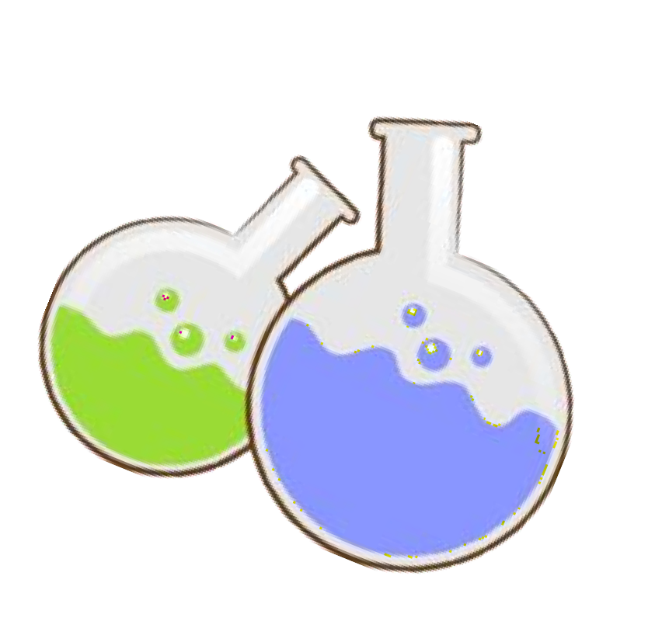

**Science Department 2023/2024**

**Year 2**

**Term 1, Week 7**

**Name: ………………………………………………….**

**Class: ……………………………………………………**



pull

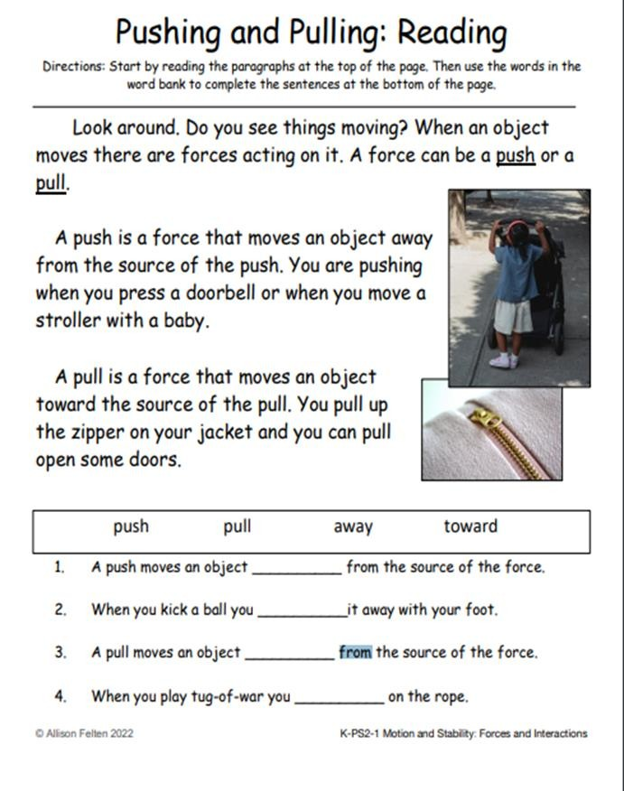

toward

Push

away



Down

Slow

up

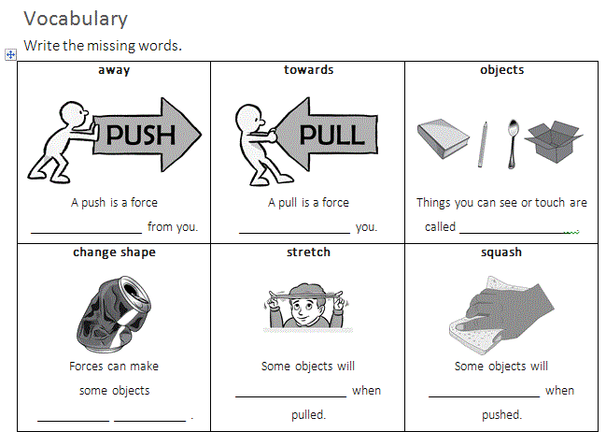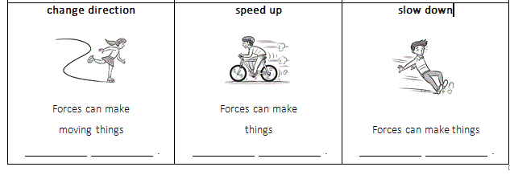

speed

direction

change

squash

stretch

shapes

change

objects

towards

away

# Choose the correct answer:



1. Forces can make things -------------- or stop. (move- fall)

move

1. We need ------------- force to push a gigantic rock. (small- big)

big

1. A ------------- force is used to push the ball. (small- big)

small

1. A pull is a force -------------------------. (away from you- towards you)

Towards you

1. I -------------- my kite so it won’t fly away. (pull –Push)

pull

# Write the correct force next to each picture, push or pull:

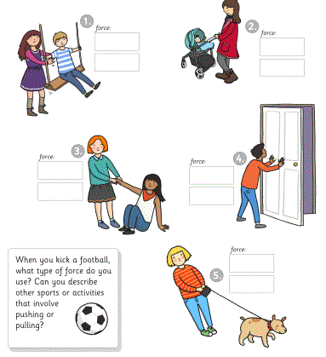

push

push

push

pull

pull

push