**Name: ---------------------------------**

**Class: ----------------------------------**



# **Comprehension:**

# **Exploring Under the Sea**

Welcome to the amazing world beneath the waves, where

many amazing animals call the sea their home.

Have you ever wondered how some sea animals hide

from their enemies? One incredible way is called

camouflage. Camouflage helps animals to hide by changing

their colour and shape to match the place they are in.

Seahorses don’t scaly bodies. Their skin matches

the colours of the coral they live in. Making it hard for

their enemies to find.

They have a curly tail. This tail helps seahorses to hold

onto sea plants so they could catch shrimps to eat.

Male seahorses have a special pouch on their bellies where

they carry their babies. This pouch protects the eggs.

Questions:

1. How do some sea animals hide from their enemies.
2. Camouflage

B. Swim fast

C. Sleep with one eye open

1. Camouflage helps the animals to
2. Sleep
3. Eat
4. Hide
5. How do animals camouflage?

Changing their shape and color to match the place they are in.

1. True or False?

The seahorse has a scaly body. False

1. Seahorses ------------------ matches the -------------- of the coral they live in.
2. True or False?

Seahorses have a straight tail. False

1. How do seahorses hold on to the plants?

By their tails.

1. What do male seahorses have?
2. Pocket B. Belt C. Pouch
3. What do male seahorses carry? eggs
4. What do seahorses eat? shrimps

**Grammar:**

Find the plural nouns with “s” and underline them.

Read the passage and circle the following words:

|  |  |  |  |
| --- | --- | --- | --- |
| scaly | camouflage | curly tail | pouch |

1. Write each word in a sentence.

Pouch: Sentences may vary

Curly tail: Sentences may vary

Look at the picture and write 2 sentences to describe the seahorse.

Adjectives to use: Size, shape, colour

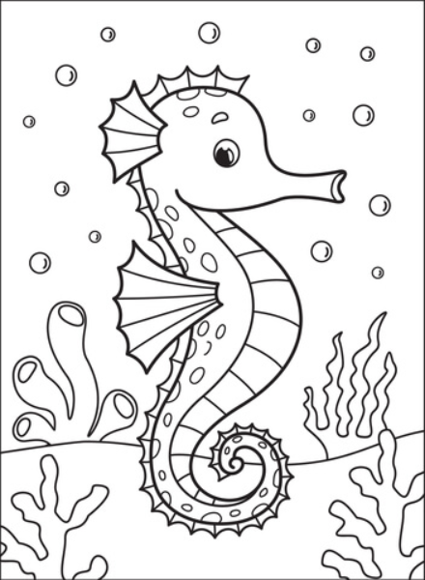

Sentences may vary

____________________________________________