**LO: I can identify the meanings of my new words and write a sentence for each word.**

**1-cunning:** 

**______________________________________________________________**

**2-clever:**  

**3-wicked:** 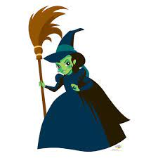

**4-brave:** 

**___________________________________________________________**