

Year 2

Unit 2

The Olympics

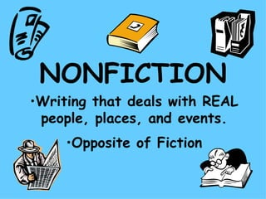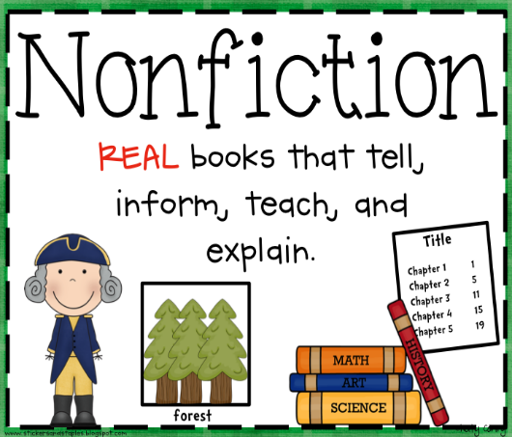

English



**Name________**



**_ _____________** ___________________________

**Spelling Words Term1 – Week 5**

**Term1 – Week 5**

|  |  |  |  |  |  |  |
| --- | --- | --- | --- | --- | --- | --- |
|  | **Words ending in (dge)** | Sunday | Monday | Tuesday | Wednesday | Thursday |
| 1 | **badge** |  |  |  |  |  |
| 2 | **edge** |  |  |  |  |  |
| 3 | Quick Stain Removal Without Washing **Splodge** |  |  |  |  |  |
| 4 | Lodge Definition & Image | GameSmartz **Lodge** |  |  |  |  |  |
| 5 | **Nudge**  **(push)** |  |  |  |  |  |
| 6 | **C:\Users\LENOVO\AppData\Local\Microsoft\Windows\INetCache\Content.MSO\CF5E829B.tmpFudge** |  |  |  |  |  |
| 7 | **Smudge**  Quick Stain Removal Without Washing |  |  |  |  |  |
| 8 | **edge** |  |  |  |  |  |
| 9 | **bridge** |  |  |  |  |  |
| 10 | **fridge** |  |  |  |  |  |

**Choose 5 words and write them in a sentence:**

**1-______________________________________________________________________________________**

**2-_______________________________________________________________________________________**

**3-______________________________________________________________________________________**

**4-______________________________________________________________________________________**

**5-_______________________________________________________________________________________**

**Look at the pictures and write the right word**

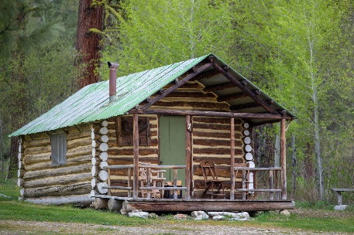



____________________________ ________________________ __________________________

**Bonus Words**

because

suddenly