**Spelling Words Term 2 – Week 4 (HW 1)**

**Term1 – Week 5**

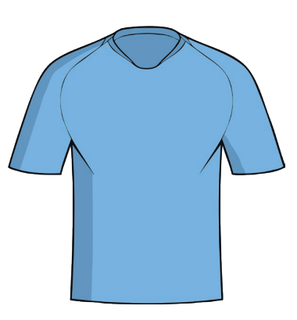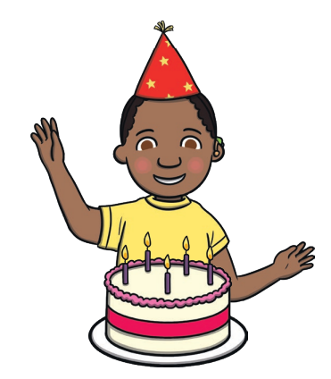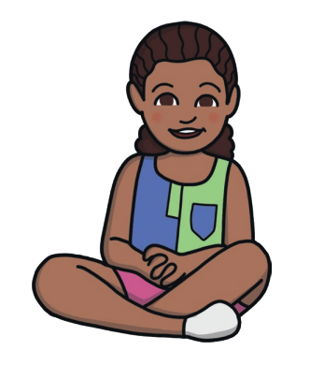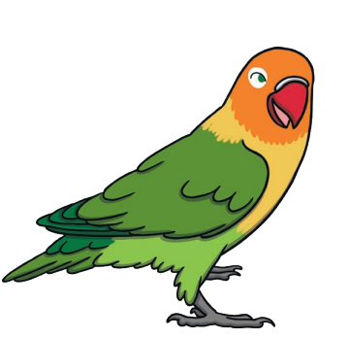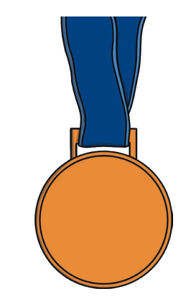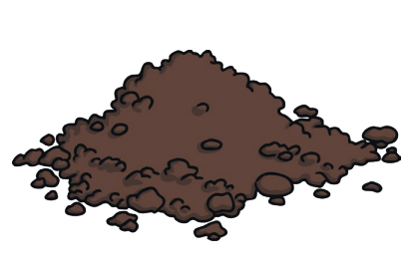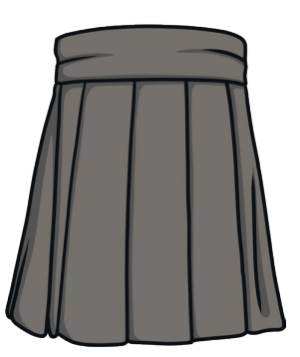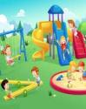

|  |  |  |  |  |  |  |
| --- | --- | --- | --- | --- | --- | --- |
|  | **Words with ir** | Sunday | Monday | Tuesday | Wednesday | Thursday |
| 1 | girl |  |  |  |  |  |
| 2 | skirt |  |  |  |  |  |
| 3 | dirt |  |  |  |  |  |
| 4 | third |  |  |  |  |  |
| 5 | bird |  |  |  |  |  |
| 6 | twirl |  |  |  |  |  |
| 7 | stir |  |  |  |  |  |
| 8 | birthday |  |  |  |  |  |
| 9 | first |  |  |  |  |  |
| 10 | shirt |  |  |  |  |  |

Wednesday and Thursday write the words in alphabetical order.

**Choose 5 words and write them in a sentence: (HW 2)**

**1-______________________________________________________________________________________**

**2-_______________________________________________________________________________________**

**3-______________________________________________________________________________________**

**4-______________________________________________________________________________________**

**5-_______________________________________________________________________________________**

**Complete the sentences using the words in the box.**

|  |  |  |  |  |
| --- | --- | --- | --- | --- |
| **bird** | **girl** | **shirt** | **third** | **skirt** |

1. The ------------- wore a pretty -------------- today.
2. The boy’s ------------- was blue and red.
3. I came in --------------- place.
4. The -------------- sat on the green fence.
5. We --------------- wood to make a hot fire.

**Bonus Words**

he

she

**Write the words under the correct picture (CW)**

|  |  |  |  |
| --- | --- | --- | --- |
| dirt | third | twirl | stir |
| bird | girl | skirt | first |
| shirt |  |  |  |

|  |  |  |
| --- | --- | --- |
|  |  |  |
| '  : |  |  |
|  |  |  |

**Fill in the missing letters to complete the word. (HW3)**

|  |  |  |
| --- | --- | --- |
| - - - - t | b - - - | sk - - - - |
| '  :  sh - - - | tw - - l | th - - - |