Needs of a Flower

*What does a flower need to grow? Fill in the boxes to show the needs of a flower or plant. You can paste craft items, paste the picture.*

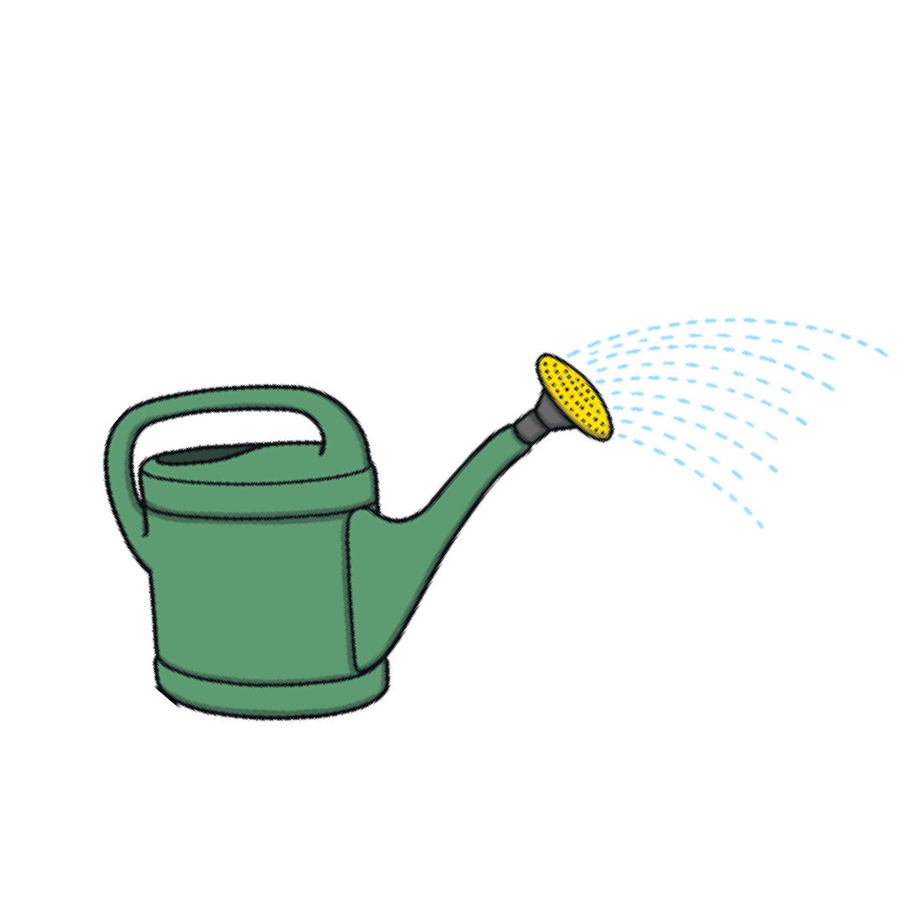

***Sun***

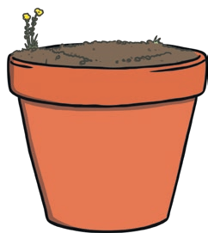

***Food***

***Water***

[**visit twinkl.com.au**](https://www.twinkl.com.au/resources/australian-resources-sen/teaching-and-support-inclusive-education-australia/teacher-organisation-sen-australia)



[**twinkl.com**](https://www.twinkl.com.au/resources/australian-resources-sen/teaching-and-support-inclusive-education-australia/teacher-organisation-sen-australia)

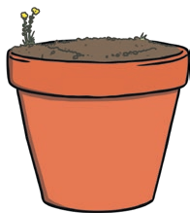

[**twinkl.com**](https://www.twinkl.com.au/resources/australian-resources-sen/teaching-and-support-inclusive-education-australia/teacher-organisation-sen-australia)



[**twinkl.com**](https://www.twinkl.com.au/resources/australian-resources-sen/teaching-and-support-inclusive-education-australia/teacher-organisation-sen-australia)



[**twinkl.com**](https://www.twinkl.com.au/resources/australian-resources-sen/teaching-and-support-inclusive-education-australia/teacher-organisation-sen-australia)

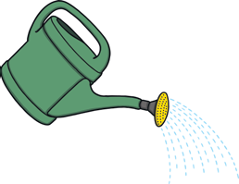

[**twinkl.com**](https://www.twinkl.com.au/resources/australian-resources-sen/teaching-and-support-inclusive-education-australia/teacher-organisation-sen-australia)

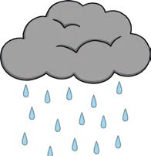

[**twinkl.com**](https://www.twinkl.com.au/resources/australian-resources-sen/teaching-and-support-inclusive-education-australia/teacher-organisation-sen-australia)



[**twinkl.com**](https://www.twinkl.com.au/resources/australian-resources-sen/teaching-and-support-inclusive-education-australia/teacher-organisation-sen-australia)