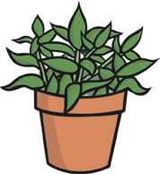

**What Do Plants Need?**

1. You can help give the plant what it needs. Cut and paste the four items that a plant needs to survive.
2. Cut and paste the three items a plant doesn’t need.

|  |  |
| --- | --- |
|  |  |
|  |  |

|  |  |
| --- | --- |
|  |  |
|  | 3. Draw something a plant doesn’t need. |

|  |  |  |  |
| --- | --- | --- | --- |
| [**twinkl.com**](https://www.twinkl.co.uk/resources/australian-resources-f-2-science-biological-sciences/living-things-needs-biological-sciences-science-f-2-australia/plants-living-things-needs-biological-sciences-science-f-2-australia) | [**twinkl.com**](https://www.twinkl.co.uk/resources/australian-resources-f-2-science-biological-sciences/living-things-needs-biological-sciences-science-f-2-australia/plants-living-things-needs-biological-sciences-science-f-2-australia) | [**twinkl.com**](https://www.twinkl.co.uk/resources/australian-resources-f-2-science-biological-sciences/living-things-needs-biological-sciences-science-f-2-australia/plants-living-things-needs-biological-sciences-science-f-2-australia) | [**twinkl.com**](https://www.twinkl.co.uk/resources/australian-resources-f-2-science-biological-sciences/living-things-needs-biological-sciences-science-f-2-australia/plants-living-things-needs-biological-sciences-science-f-2-australia) |
| [**twinkl.com**](https://www.twinkl.co.uk/resources/australian-resources-f-2-science-biological-sciences/living-things-needs-biological-sciences-science-f-2-australia/plants-living-things-needs-biological-sciences-science-f-2-australia) | [**twinkl.com**](https://www.twinkl.co.uk/resources/australian-resources-f-2-science-biological-sciences/living-things-needs-biological-sciences-science-f-2-australia/plants-living-things-needs-biological-sciences-science-f-2-australia) | [**twinkl.com**](https://www.twinkl.co.uk/resources/australian-resources-f-2-science-biological-sciences/living-things-needs-biological-sciences-science-f-2-australia/plants-living-things-needs-biological-sciences-science-f-2-australia) |  |

[Page 3 of 3](http://www.twinkl.co.uk/)

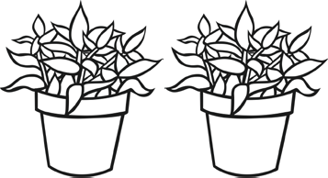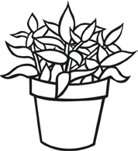

**What Do Plants Need? Answers**

1. You can help give the plant what it needs? Cut and paste the four items that a plant needs to survive.
2. Cut and paste the three items a plant doesn’t need.

|  |  |
| --- | --- |
|  |  |
|  |  |

|  |  |
| --- | --- |
|  |  |
|  | 3. Draw something a plant doesn’t need.  **Answers will vary. Teacher to check.** |



[Page 1 of 1](https://www.twinkl.co.uk/resources/australian-resources-f-2-science-biological-sciences/living-things-needs-biological-sciences-science-f-2-australia/plants-living-things-needs-biological-sciences-science-f-2-australia)

[**visit twinkl.com.au**](https://www.twinkl.co.uk/resources/australian-resources-f-2-science-biological-sciences/living-things-needs-biological-sciences-science-f-2-australia/plants-living-things-needs-biological-sciences-science-f-2-australia)