Spelling Words Term1 – Week 8

Term1 – Week 5
 | Words beginning with wr- The w is silent | Sunday | Monday | Tuesday | Wednesday | Thursday
1 | write
2 | Wrench  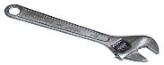
3 | wrap
4 |   Wreck
5 |   Wrinkle
6 | 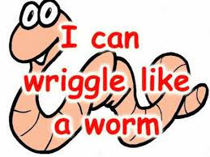  Wriggle
7 | Wrestle  
8 | Wren  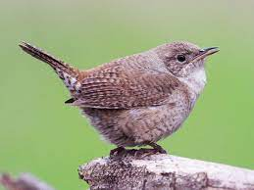
9 | wrist
10 | wripped

Choose 5 words and write them in a sentence:

1-______________________________________________________________________________________

2-_______________________________________________________________________________________

3-______________________________________________________________________________________

4-______________________________________________________________________________________

5-_______________________________________________________________________________________

Find the spelling mistake in each sentence then write the word again.

1-I rite with my pencil. _____________________
2-I can riggle like a worm. ____________________
3-I love to rap the gifts. __________________
4-My grandma has rinkles on her face. ____________
5-Dina hurt her rist when she fell. _______________

Bonus Words

asked
thought

