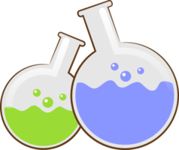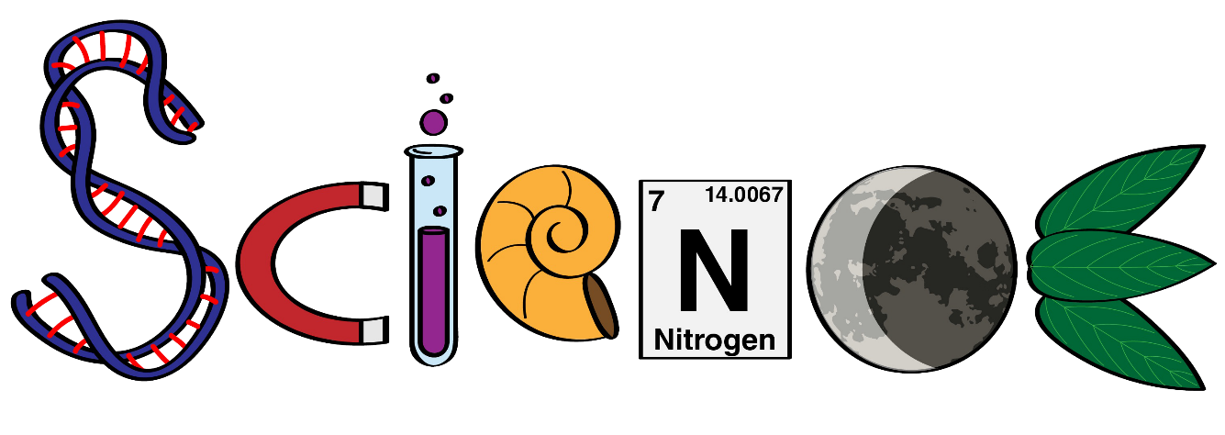

**Name: ………………………………………………….**

**Class: ……………………………………………………**

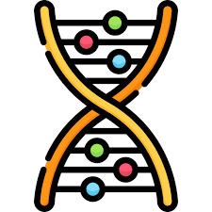

**Science Department**

**2023/2024**

**Year 2**

**Term 2, Week 9**

**Worksheets**

1. **Choose the correct answer:**
2. The main natural source of light is the -----------------.
3. Moon b) Sun c) bulb
4. A light --------------------- is an electric source of light.
5. torch b) sun c) flame
6. ----------------------- reflects light.
7. Sand b) Glass c) Paper
8. The --------------------- reflects light from the Sun. It doesn’t make light.
9. earth b) moon c) floor
10. Never look at the ------------------------ as it will hurt your eyes.
11. sun b) stars c) mars
12. Materials which ----------------------- a lot of light look bright.
13. reflect b) absorb c) hurt
14. **Circle the light source :**

