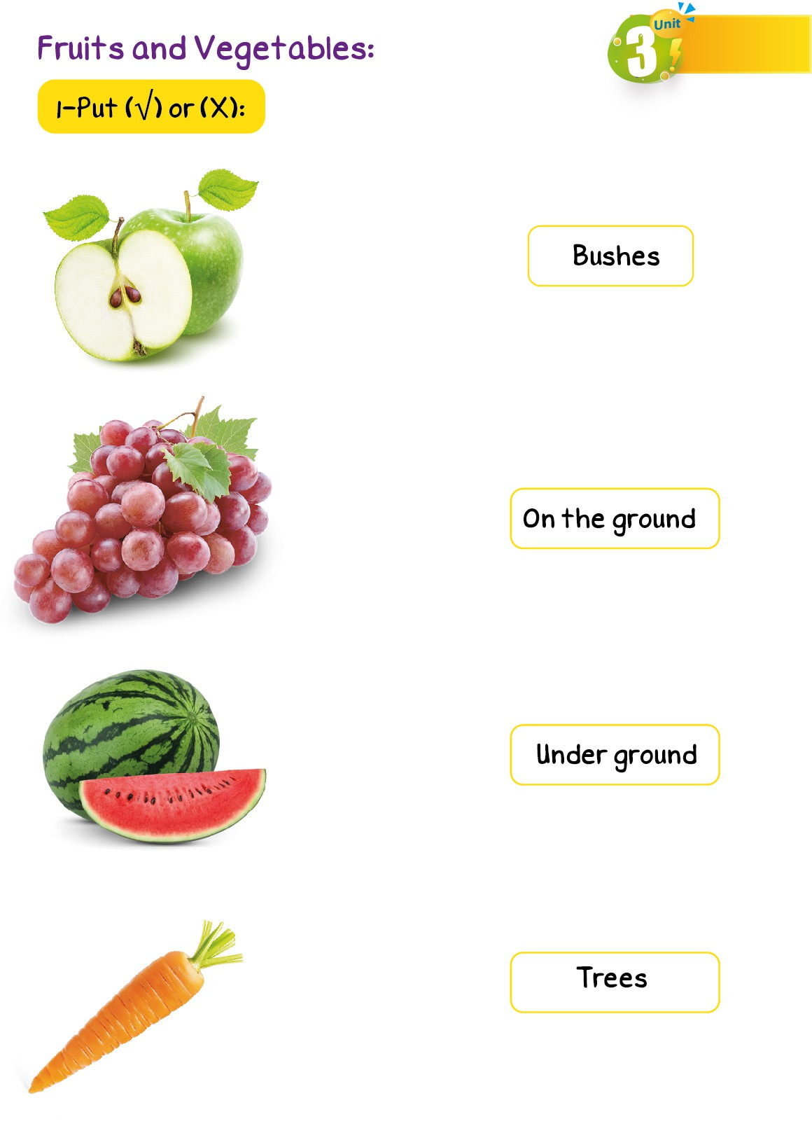

**1-Match each fruit or vegetable with the place it came from:**