**NAME:_________________________________________________**

**Date:__________________________________________________**

**Read and Match:**

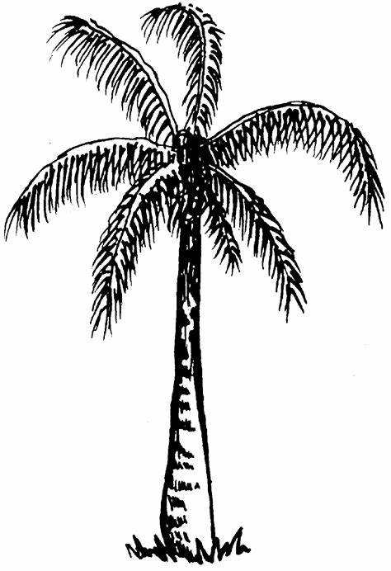

**Bushes**

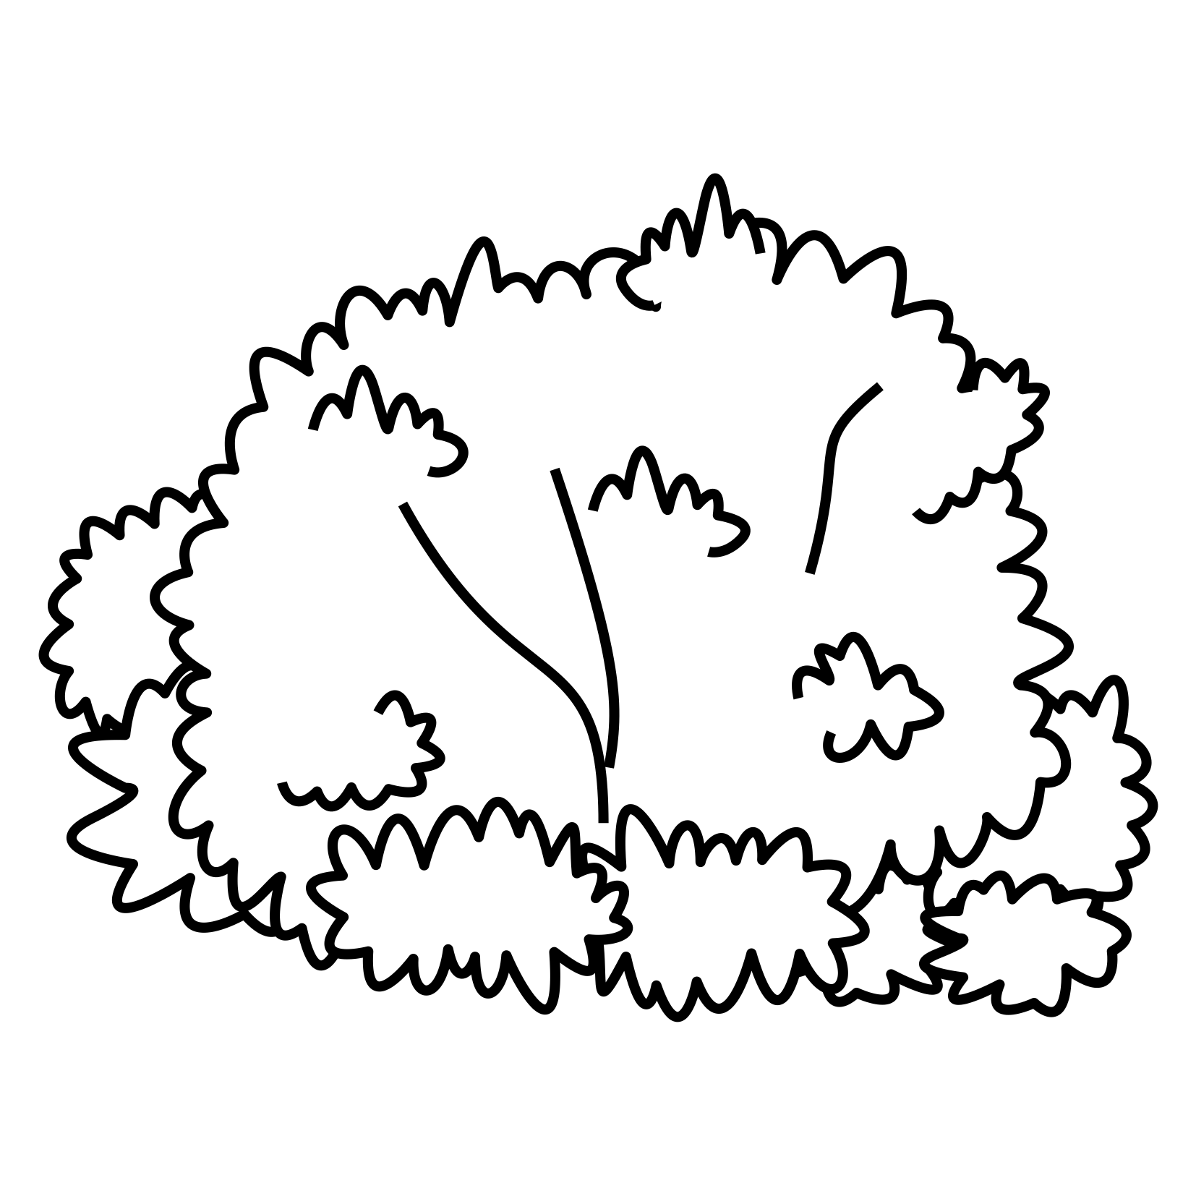

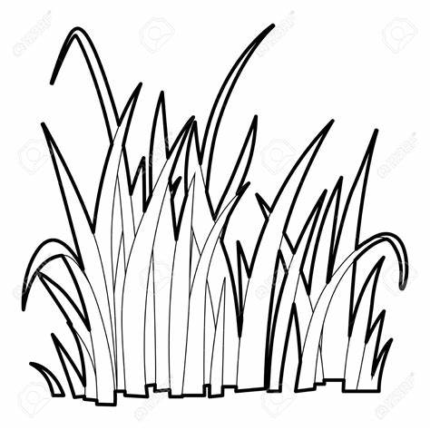

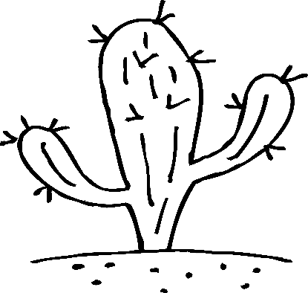

**Cactus**

**Palm tree**

**Grass**