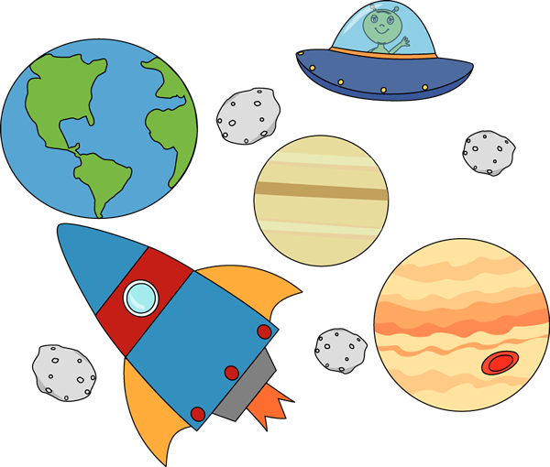

**Instructions**

**Imagine that you travelled to the space. Write about your adventure.**

1-Write a paragraph to describe the setting (**time and place**) of the place.

2-Write a paragraph about the beginning of the story.

3- Write a paragraph about the middle of the story.

4- Write a paragraph about the end of the story.

-Don’t forget to use your writing rules (**capital letter- finger spaces and full stops**).

-Don’ forget to use adjectives (**gigantic- enormous- spooky- eerie- magnificent- curious-dark-mysterious-terrified**)

-Don’t forget to use connectives (**and- but- or- suddenly- because- when- next- after that- then**)

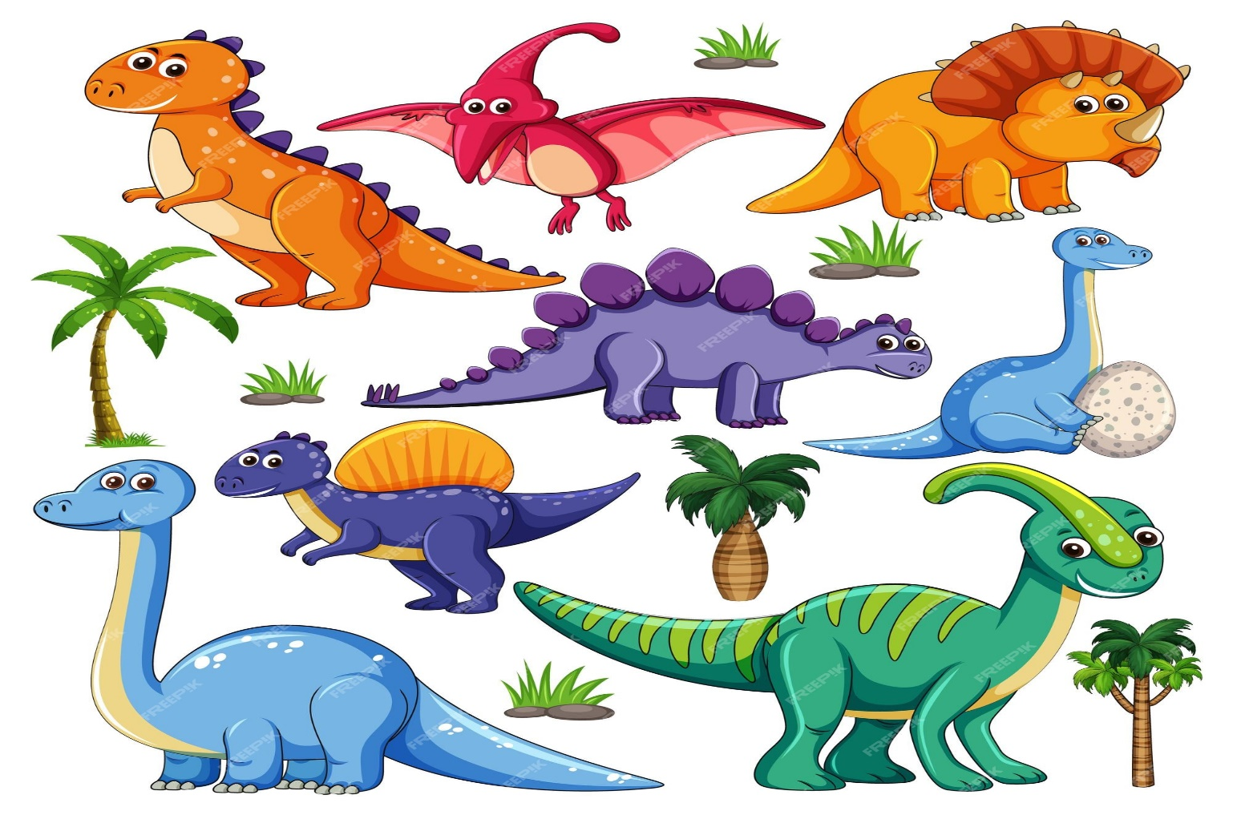

**Instructions**

**Imagine that you travelled to the space. Write about your adventure.**

1-Write a paragraph to describe the setting (**time and place**) of the place.

2-Write a paragraph about the beginning of the story.

3- Write a paragraph about the middle of the story.

4- Write a paragraph about the end of the story.

-Don’t forget to use your writing rules (**capital letter- finger spaces and full stops**).

-Don’ forget to use adjectives (**gigantic- enormous- spooky- eerie- magnificent- curious-dark-mysterious-terrified**)

-Don’t forget to use connectives (**and- but- or- suddenly- because- when- next- after that- then**)