**Spelling Words Term1 – Week 12**

**Term1 – Week 5**

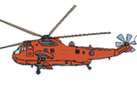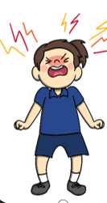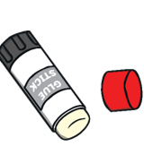

|  |  |  |  |  |  |  |
| --- | --- | --- | --- | --- | --- | --- |
|  | **Words ending in ue** | Sunday | Monday | Tuesday | Wednesday | Thursday |
| 1 | glue |  |  |  |  |  |
| 2 | blue |  |  |  |  |  |
| 3 | true |  |  |  |  |  |
| 4 | argue |  |  |  |  |  |
| 5 | rescue |  |  |  |  |  |
| 6 | statue |  |  |  |  |  |
| 7 | clue |  |  |  |  |  |
| 8 | queue |  |  |  |  |  |

**Choose 5 words and write them in a sentence:**

**1-______________________________________________________________________________________**

**2-_______________________________________________________________________________________**

**3-______________________________________________________________________________________**

**4-______________________________________________________________________________________**

**5-_______________________________________________________________________________________**

**Complete the sentences using the words in the box.**

|  |  |  |  |  |  |
| --- | --- | --- | --- | --- | --- |
| **glue** | **statue** | **true** | **argue** | **rescue** | **blue** |

1. I have a _______________ stick.
2. I saw a _______________ bird on the tree.
3. She said that it might be ______________.
4. This _______________ is made of wood.

5-They shouted for help, but nobody came to ____________them.

**Bonus Words**

saw

said