Colour the picture according to the following key: (HW)

Adjectives: Red Nouns: Yellow Verbs: Green

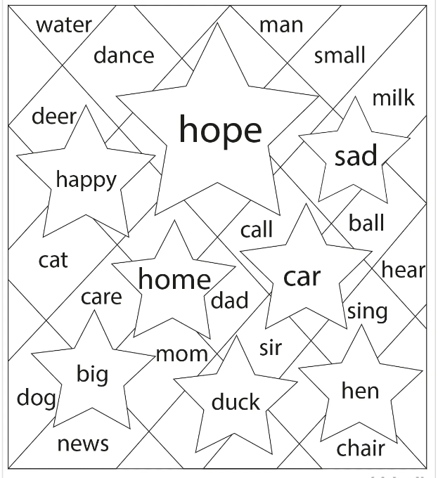

Colour the picture according to the following key: (HW)

Adjectives: Red Nouns: Yellow Verbs: Green

