Performance Assessment Task (Report)
Name: Yasmine Mohamed Grade: 2
Subject: English, Math and Science

Task
-Children will do a project about habitat. This project should integrate the three subjects together; English, Math and Science.
-Each subject will meet some objectives and the children will be assessed according to these objectives.
-The project will be done in the classroom under the supervision of the teacher so she could assess them easily. Children will be asked to provide some materials and objects for their own project.

Objectives in Science:
- Know that a model represents an object or idea in a clear way.
- Make and use a physical model of a familiar system or idea.
- Collect and record observations or measurements by annotating images and completing simple tables.

Objectives in Math:

- Conduct an investigation to answer non-statistical and statistical questions
- Record, organize and represent data using a tally chart and a Carroll diagram.
- Describe data and discuss conclusions.
- Describe data and identify similarities and differences within discussions.
- Able to say which representation would be the best to use in a given situation.

Objectives in English:

- Include additional information to develop some ideas when writing non-fiction texts.
- Use vocabulary relevant to a familiar topic. *
- Use simple organisational features appropriate to the text type, e.g., subheadings, labelled diagrams. *
- Talk about own activities, including why they made particular choices.
- Record key information drawn from a non-fiction text, e.g., listing key topic words.
- Begin to write for a purpose using basic language and features appropriate for the text type. *
- Include additional information to develop some ideas when writing non-fiction texts.

Requirement of your research report:
1. Have a title page with your name, class, date and title.
2. Your research should be divided into 3 parts, organized as follows:
- Introduction:
Introduce your concept and some basic information about it.
-What is a habitat?
-What kind of habitat did you choose?
- Body:
-Make a research and write some facts about your own habitats;
-Describe your own habitat.
-What animals could live there.
-What kind of plants could survive there.
-What special about your own habitat.
- Conclusion:
Conclude your research by expressing your opinion about what you found out.
-Compare your habitat with other habitats.
-Make a tally chary and a Carroll diagram to record, organize and represent data.

Model of the project
Subject | Example | Objective
Science | -Children will choose their own favorite habitat and design it using different materials.
Math | 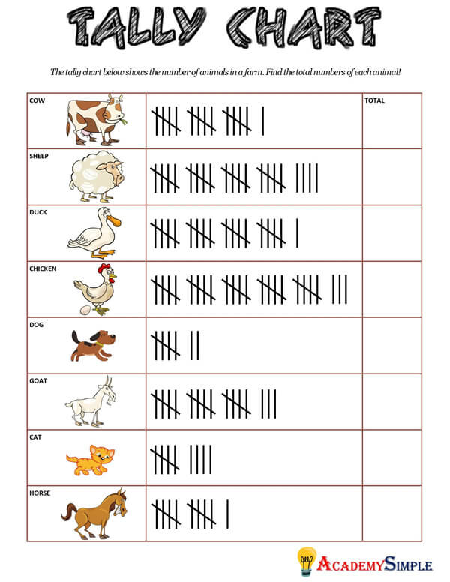  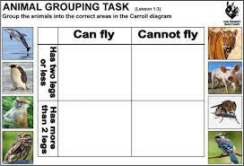 | -Children will record, organize and represent data using a tally chart and a Carroll diagram.
English | 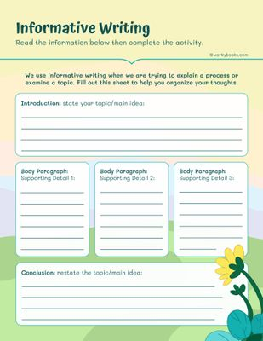 | - Hi - Children will talk about own  activities, including  why they made particular choices and additional information to develop some ideas when writing non-fiction texts.

Rubrics of the project
Criteria | 1 | 2 | 3 | 4 | 5
Science | The student demonstrates no understanding of habitats and does not describe any key features or characteristics accurately | The student demonstrates a limited understanding of habitats, describing a few key features and characteristics accurately | The student demonstrates a basic understanding of habitats, describing some key features and characteristics accurately. | The student demonstrates a good understanding of habitats, describing most key features and characteristics accurately. | The student demonstrates a thorough understanding of habitats, accurately describing key features and characteristics
Math | The student does not demonstrate any understanding of how to use a tally chart and Carroll diagram. | The student demonstrates a limited understanding of how to use a tally chart and Carroll diagram, with several inaccuracies | The student demonstrates a basic understanding of how to use a tally chart and Carroll diagram, but some inaccuracies are present. | The student demonstrates a good understanding of how to use a tally chart and Carroll diagram to classify animals accurately. | The student demonstrates a good understanding of how to use a tally chart and Carroll diagram to classify animals accurately.
English | The writing is completely disorganized and lacks any structure. | The writing is disorganized and lacks clear structure. | The writing is somewhat organized, but may be missing an introduction, body, or conclusion | The writing is mostly well-structured with an introduction, body, and conclusion, but may lack some clarity. | The writing is well-structured with a clear introduction, body, and conclusion

Materials needed for the project for each child
-Children should decide what kind of habitat they want to design then they get its materials accordingly.
Habitat | Example | Materials needed
Jungle | 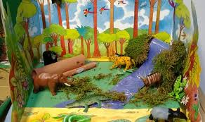 | 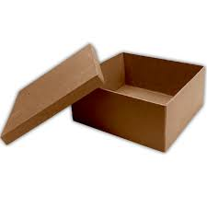  1-One box (medium size) with a separate lid.  2-Jungle animals (plastic ones if possible or some pictures for different animals.  3-some small rocks and sand.  4-4 glue sticks.
Arctic | 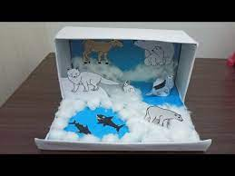 | 1-One box (medium size) with a separate lid.  2-Arctic animals (plastic ones if possible or some pictures for different animals.  3-One pack of white cotton.  4-wooden sticks.  5-4 glue sticks.
Under the sea | 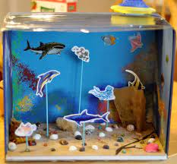 | 1-One box (medium size) with a separate lid.  2-Under the sea animals (plastic ones if possible or some pictures for different animals.  3-Some rocks and sand  4-wooden sticks.  5-Some shells.  6-4 glue sticks.
Desert | 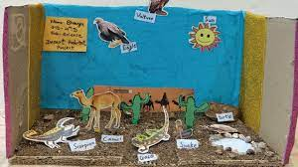 | 1-One box (medium size) with a separate lid.  2-Desert animals (plastic ones if possible or some pictures for different animals.  3-Some rocks and sand  4-wooden sticks.  5-4 glue sticks.

