comprehension Revision Pack Term 1

English Year 2 2022/2023

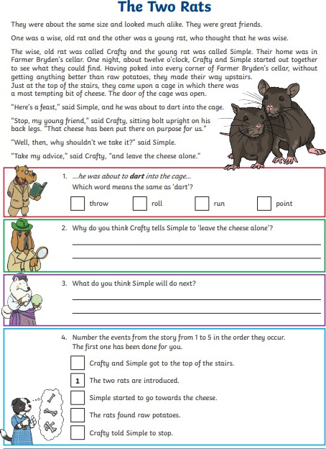

**2**

**5**

**4**

**3**

**Simple will not listen to Crafty and will dart into the cage to take the cheese.**

**Because the cheese has been put there on purpose for them.**

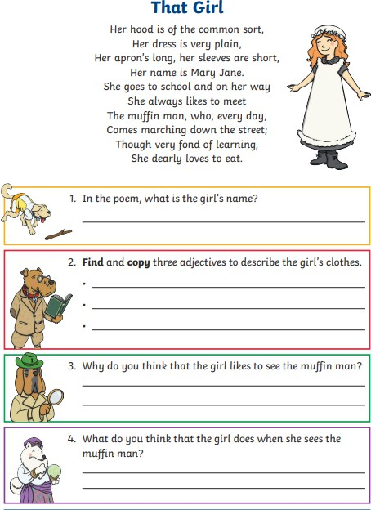

**she smiles and prepares her money to buy from him.**

**Because she loves to eat muffin.**

**Plain / long / short.**

**Her name is Mary Jane.**

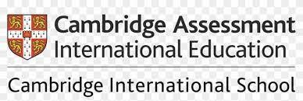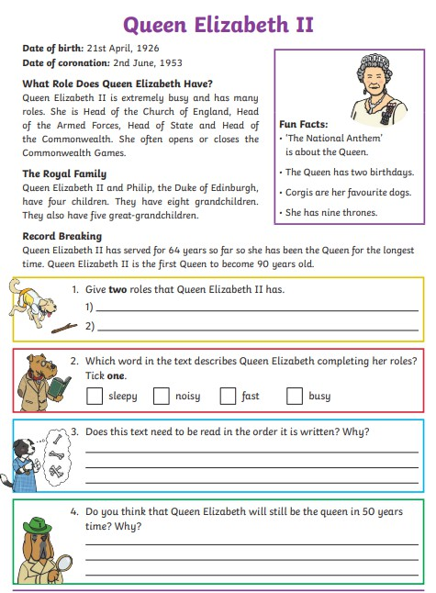

**She is Head of the Church of England.**

**She is Head of the Armed Forces.**

**No, because it is a non-fiction text.**

**No, because she has already served for 64 years.**

Plot No.2/ Al-Banafseg Services Center No.2 First Settlement- New Cairo

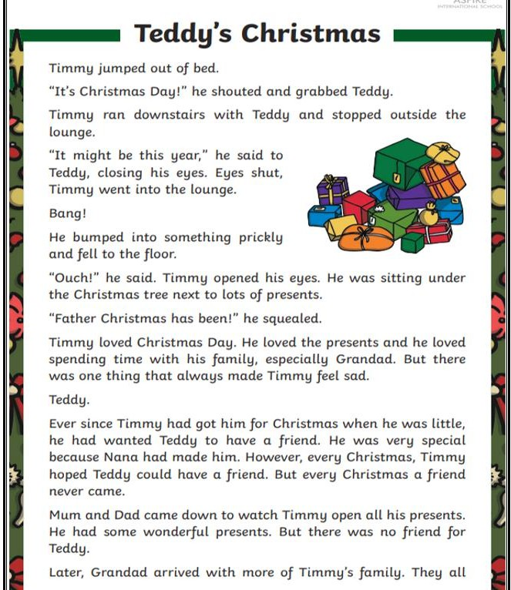

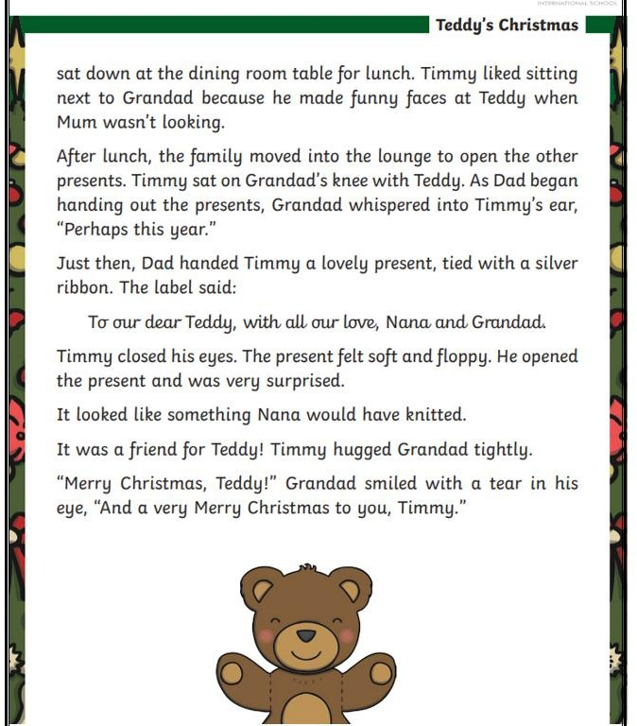

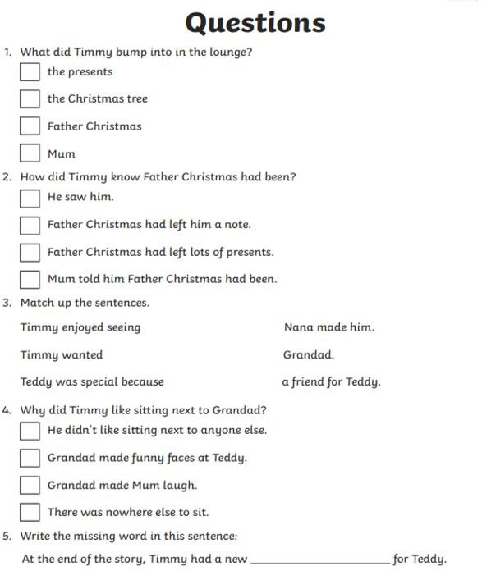

**friend**

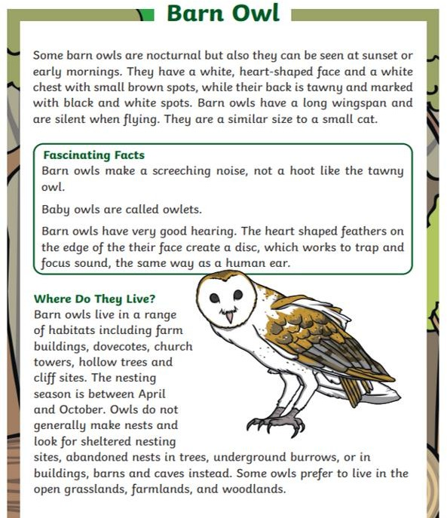

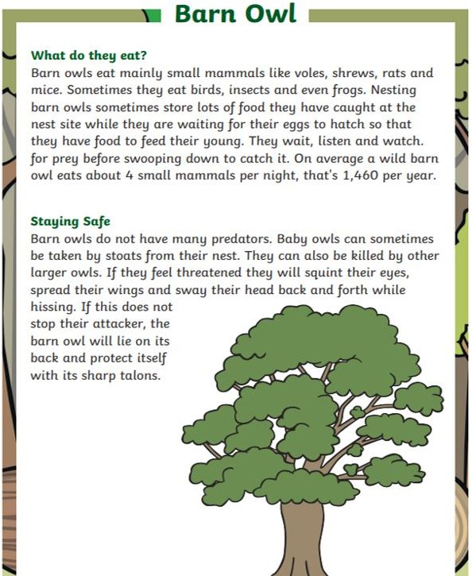

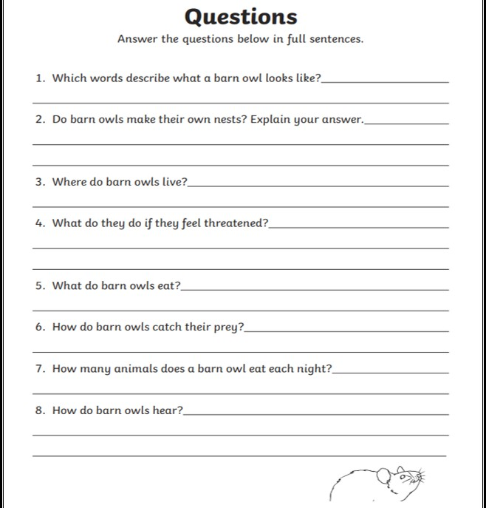

**They have very good hearing.**

**They eat about 4 small mammals per night.**

**They wait, listen and watch for prey before swooping down to catch it.**

**They eat mainly small mammals like voles, shrews, rats and mice.**

**They will squint their eyes, spread their wings and sway their head back and forth while hissing.**

**They live in a range of habitats including farm buildings, dovecotes, church towers, hollow trees and cliff sites.**

**No, they for sheltered nesting sites, abandoned nests in trees, underground burrows, or in buildings, barns and caves .**

**They have a white heart-shaped face and a white chest with small brown spots, while their back is tawny and marked with black and white spots.**

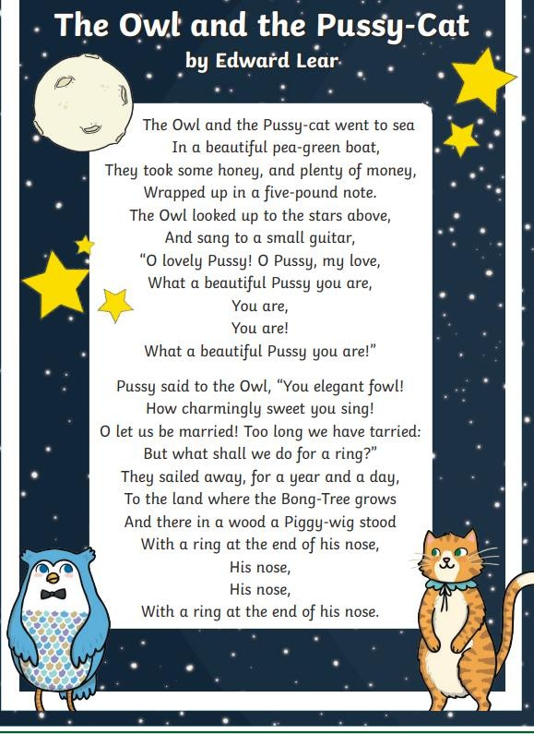

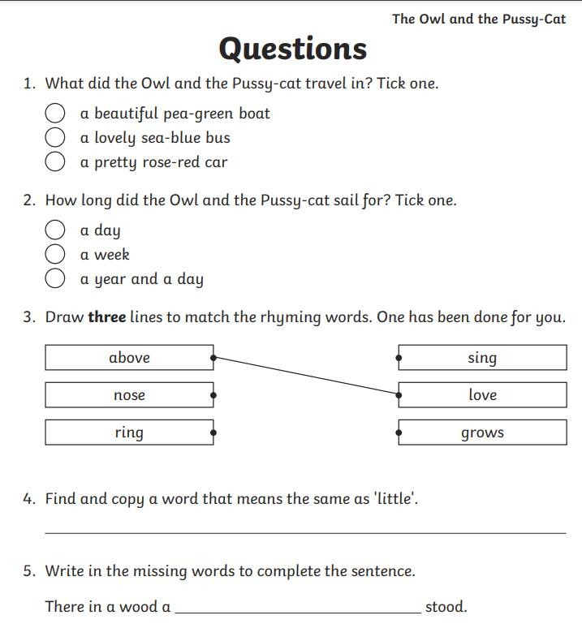

**Piggy-wig**

**small**