

Year 2

**LO: I can identify the nouns in my sentences- (Homework)**

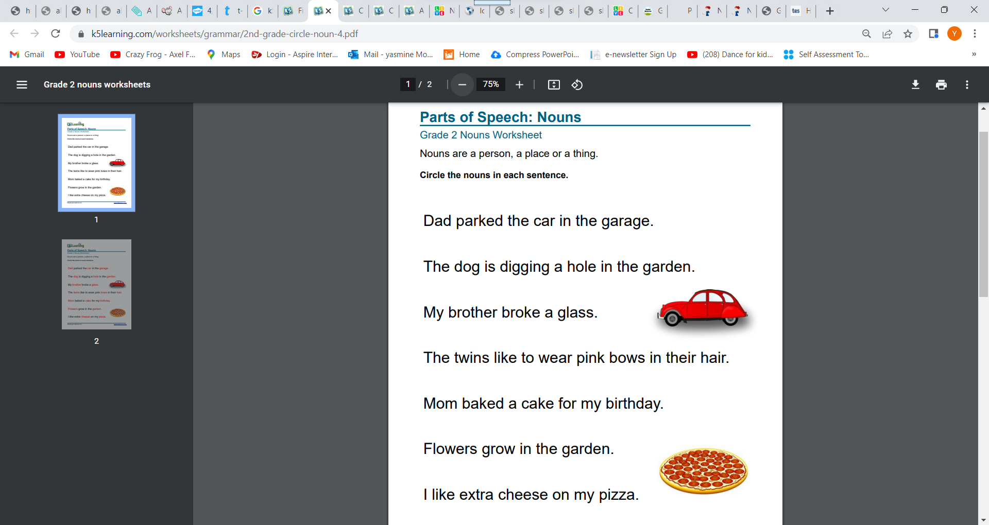

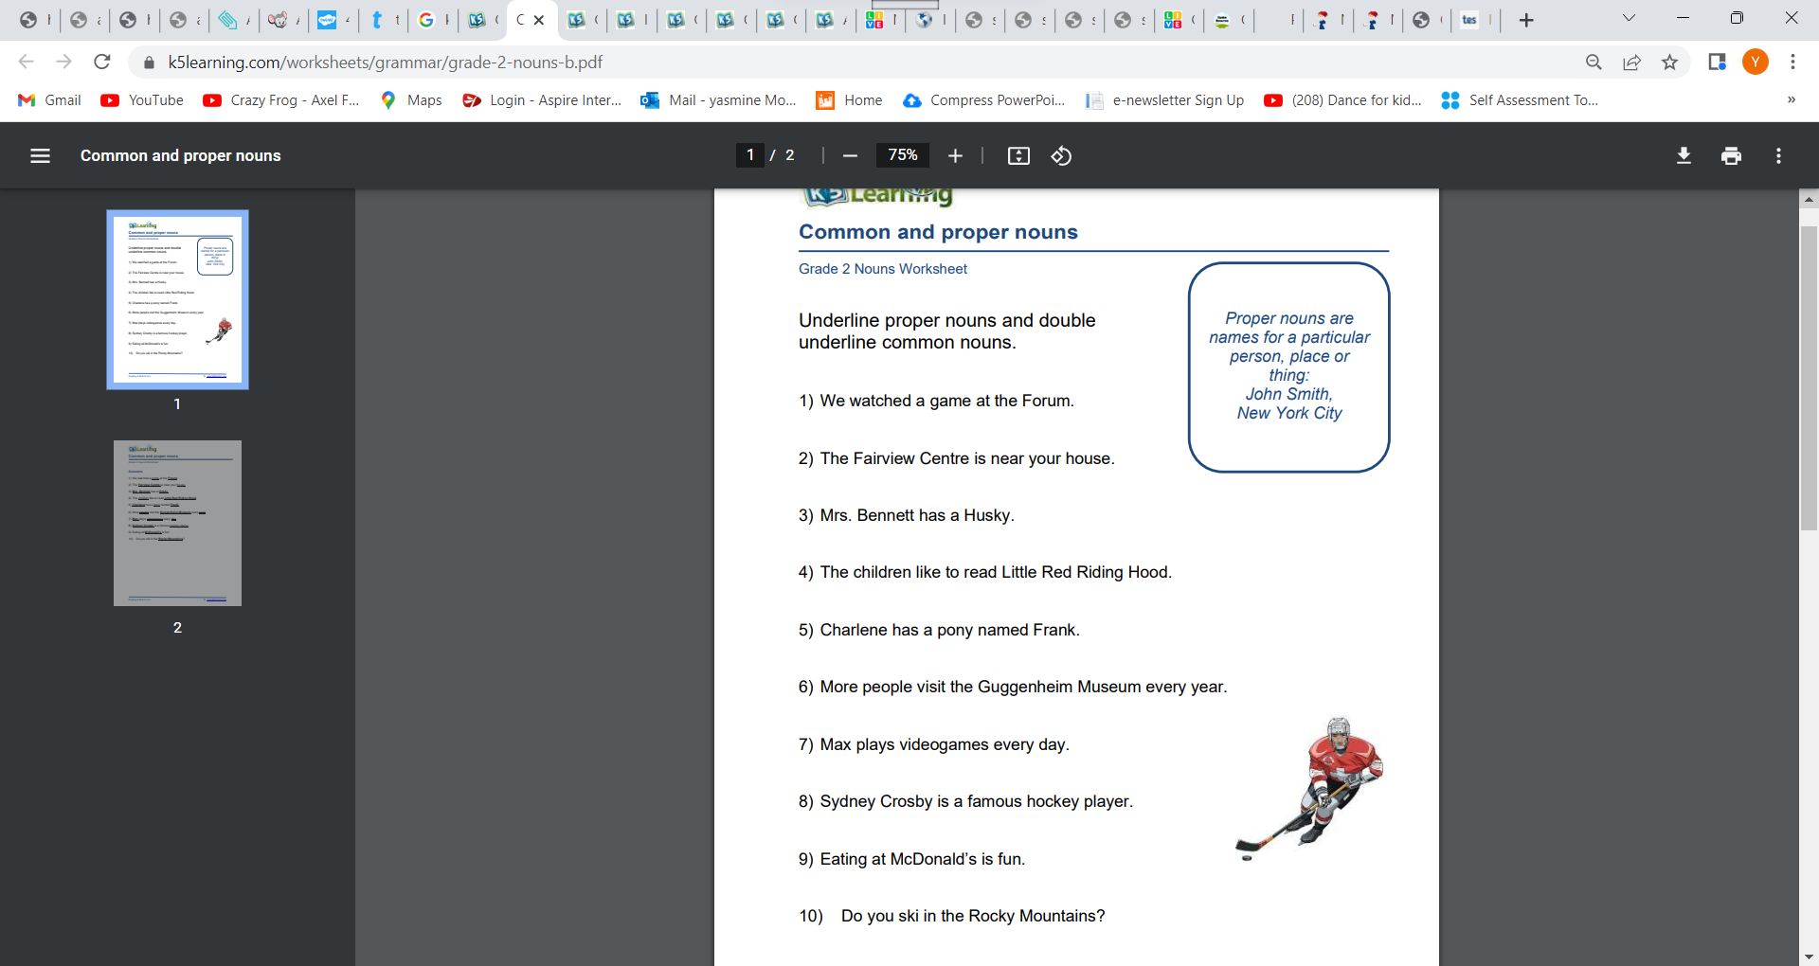**LO: I can identify the nouns in my sentences- (Classwork)**

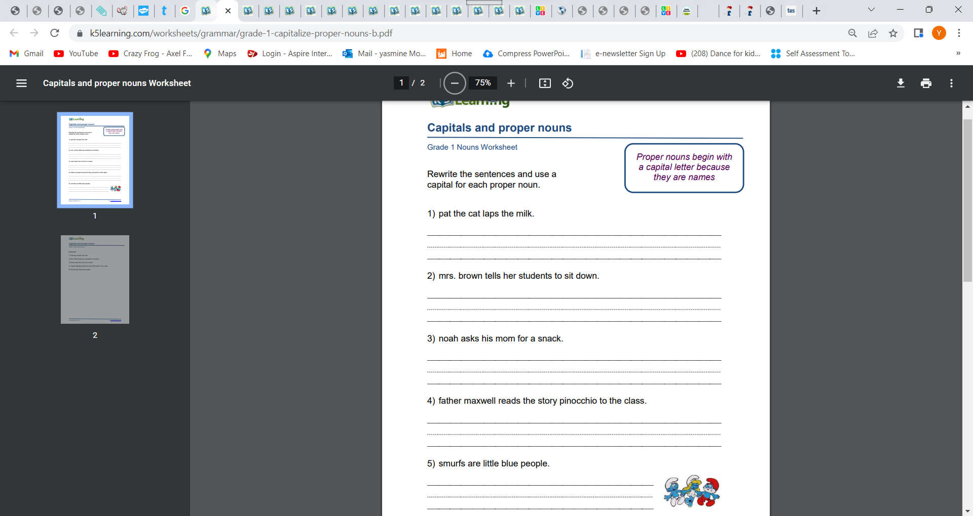**LO: I can identify the nouns in my sentences- (Classwork)**

