**My Booklet**



**Made by**: __________________

**Class:** ____________________

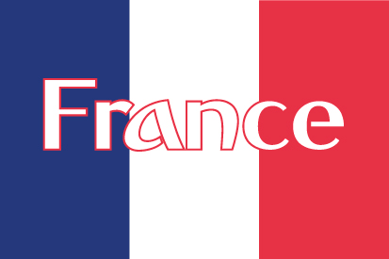

Things I know about this country I can colour The Eiffel Tower

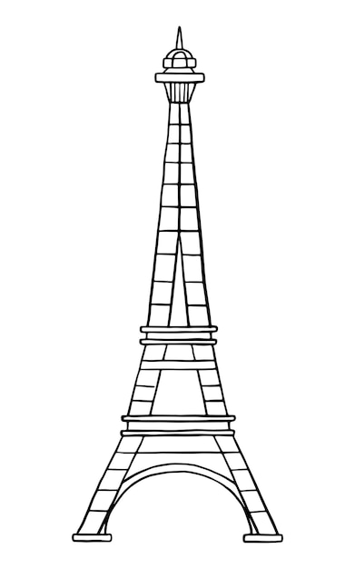___________________

___________________

____________________

____________________

____________________

____________________

____________________



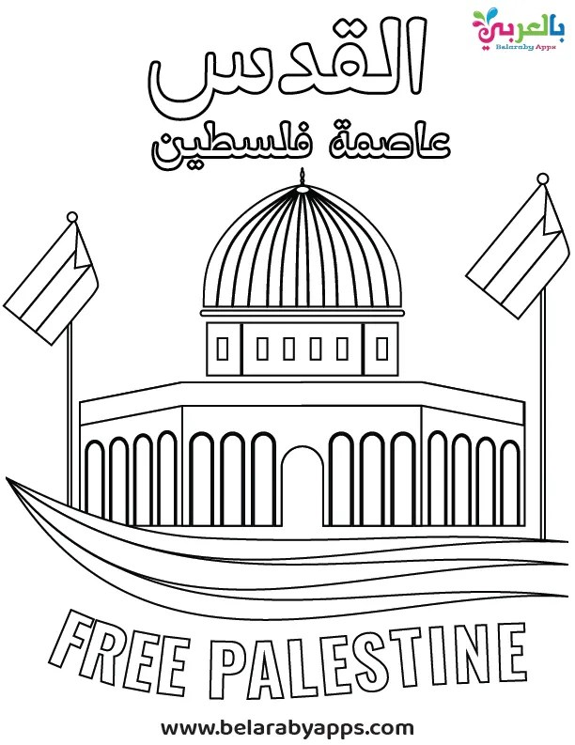

Things I know about this country I can colour the Jerusalem

____________________

____________________

____________________

____________________

____________________

____________________

____________________

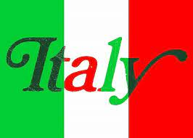

Things I know about this country I can colour the Pisa Tower

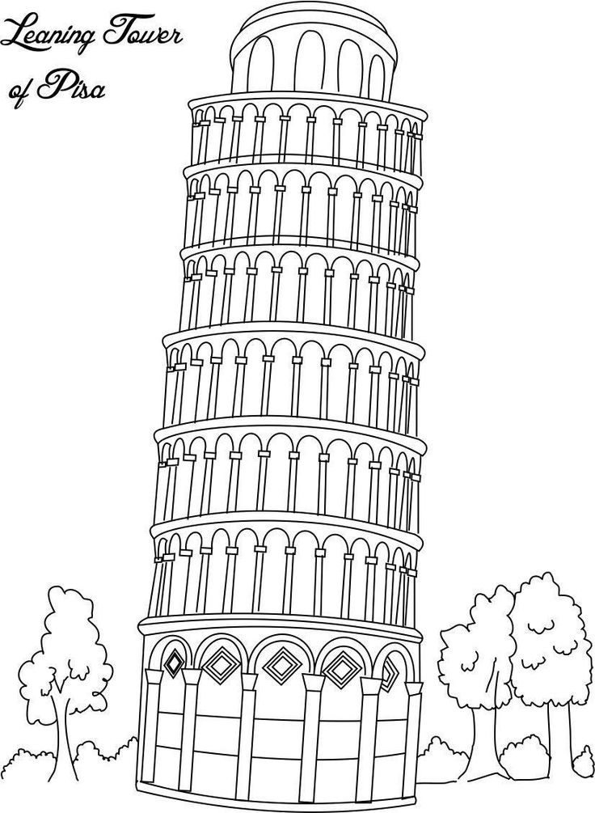

____________________

____________________

____________________

____________________

____________________

____________________

____________________

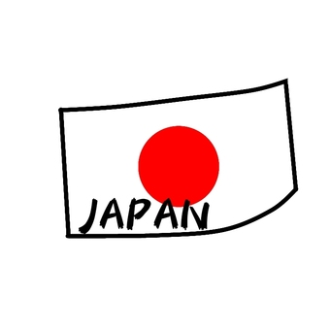

Things I know about this country I can colour the the Mount fuji

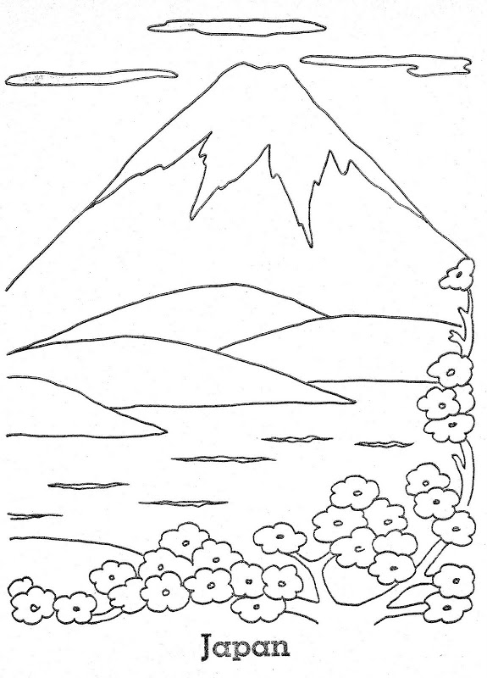

____________________

____________________

____________________

____________________

____________________

____________________

____________________



Things I know about this country I can colour the mountain.

____________________











