Vocabulary

Revision Pack

Vocabulary

Term 1

English

Year 2

2022/2023

**Week 1 and 2 Vocabulary:**

**1-Magnificent:** amazing or beautiful

**2-Gloomy:** dark

**3-Gigantic:** enormous

**4-pleased:** happy

**5-charming:** beautiful

**6-curious:** wants to know about everything

**7-delightful:** happy

**Choose the right answer from the above words:**

1-The ____________ prince is dancing with the beautiful princess.

2-The cave is so dark and ____________.

3-The ____________ elephants are walking towards the castle.

4-I have visited a __________ palace in England.

5-I am so _____________ to see you.

6-I am so _______________ to know some information about the sun.

7-It has been really ___________ when I met my uncle last summer.

**Week 3 and 4 Vocabulary:**

|  |  |
| --- | --- |
| word | picture |
| squidgy | [This Photo](https://calmlycookingcurry.blogspot.com/2015/11/ingredient-of-week-lemon-or-lime.html) by Unknown Author is licensed under [CC BY-SA](https://creativecommons.org/licenses/by-sa/3.0/) |
| fuzzy | [This Photo](http://www.flickr.com/photos/stevendepolo/6112312369/) by Unknown Author is licensed under [CC BY](https://creativecommons.org/licenses/by/3.0/) |
| knobbly | [This Photo](https://www.flickr.com/photos/foodista/3862206469/) by Unknown Author is licensed under [CC BY](https://creativecommons.org/licenses/by/3.0/) |
| rough |  |
| ingredients | [This Photo](http://dangerouslee.biz/813-the-seasoning-ingredients-hd/) by Unknown Author is licensed under [CC BY](https://creativecommons.org/licenses/by/3.0/) |
| pour | [This Photo](https://www.freeimageslive.co.uk/free_stock_image/pouring-yorkshire-pudding-jpg) by Unknown Author is licensed under [CC BY](https://creativecommons.org/licenses/by/3.0/) |
| sprinkle |  |
| whisk | [This Photo](https://www.freefoodphotos.com/imagelibrary/cooking/slides/gravy_wisk.html) by Unknown Author is licensed under [CC BY](https://creativecommons.org/licenses/by/3.0/) |
| grate | [This Photo](https://www.foodiggity.com/page/61/) by Unknown Author is licensed under [CC BY-NC-ND](https://creativecommons.org/licenses/by-nc-nd/3.0/) |
| knead |  |
| bake |  |
| stir | [This Photo](https://www.flickr.com/photos/suckamc/4349516009/) by Unknown Author is licensed under [CC BY-SA](https://creativecommons.org/licenses/by-sa/3.0/) |
| mix | [This Photo](http://www.malas-kitchen.com/2017/06/puliyogare-instant-mix-powder.html) by Unknown Author is licensed under [CC BY](https://creativecommons.org/licenses/by/3.0/) |
| spread | [This Photo](https://www.livingalifeincolour.com/recipes/bruschetta-con-fave-e-pecorino-broad-bean-and-pecorino-on-toasted-bread/) by Unknown Author is licensed under [CC BY-NC-ND](https://creativecommons.org/licenses/by-nc-nd/3.0/) |
| sieve | [This Photo](https://www.ingridscience.ca/node/338) by Unknown Author is licensed under [CC BY-SA-NC](https://creativecommons.org/licenses/by-nc-sa/3.0/) |
| chop | [This Photo](https://www.flickr.com/photos/toholio/3492618181) by Unknown Author is licensed under [CC BY-SA](https://creativecommons.org/licenses/by-sa/3.0/) |

**Write the meaning for each sentence:**

1-The rock is so hard. _______________

2-The potato does not have a specific shape. __________

3-I can’t eat this food, it is so _____________.

4-The lemon is so _____________.

5-__________ the cucumber into slices.

6-__________ the flour before you use it.

7-__________ the cheese on top of the toast.

8-__________ the food while you are cooking.

9-__________ the dough.

10-__________ the ingredients together.

11-put the cake in the oven to ___________ it.

12- You have to _________ the cheese before you ___________ it on top of the pizza.

13-___________ the egg with the milk.

14-___________ the juice in your cup.

15-mix all the ______________ together.

**Week 5 and 6 Vocabulary:**

**Eerie:** scary

**Spooky:** scary

**Enormous:** big

**Frightened:** afraid of

**Terrified:** frightened

**Sneaky:** behaving in a secret and usually dishonest manner.

**Grumpy:** sad

**Gleaming:** shinning

**Terrible:** doesn’t look nice

**Write a sentence for each word:**

**Eerie**

**________________________________________________**

**Spooky**

**___________________________________ _____________**

**Enormous**

**__________________________________________________**

**Frightened**

**__________________________________________________**

**Terrified**

**___________________________________**

**Sneaky**

**___________________________________**

**Grumpy**

**___________________________________**

**Gleaming**

**___________________________________**

**Terrible**

**___________________________________**

**Week 7 and 8 Vocabulary:**

**Astonishing:** amazing

**Embarrassed:** feeling uncomfortable

**Scrumptious:** delicious

**Greedy:** wants to take everything

**Miserable:** sad and feelinglonely.

**Cheerful:** happy

**Choose the right answer:**

1-I was so (cheerful- miserable-embarrassed) when I cried in front of everyone.

2-I got an amazing gift because my project was (miserable- astonishing- cheerful)

3- This girl is so (embarrassed- cheerful- greedy), she wants to take all the chocolate to herself.

4-This meal is so (greedy- scrumptious-embarrassed).

5-Adam is so (greedy- miserable- cheerful) because he got an astonishing gift.

6-I feel ( miserable- cheerful- astonishing) because no one wants to play with me.

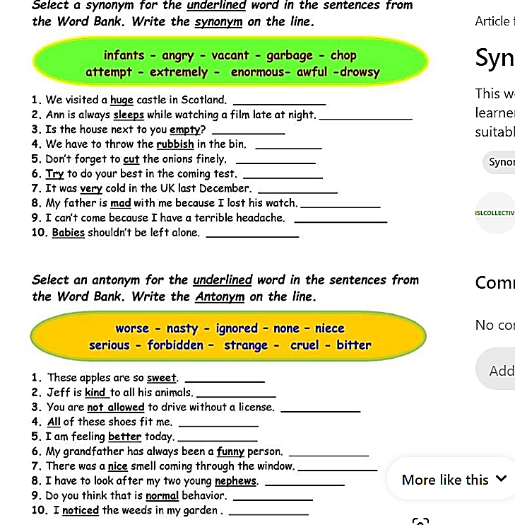

**Match the synonyms with their antonyms meaning**

**1-despair include**

**2-annoy dependent**

**3-Independent satisfy**

**4-exclude export**

**5-import hope**