**Spelling Words Term 2 – Week 9 (HW 1)**

**Term1 – Week 5**

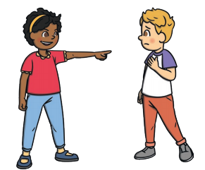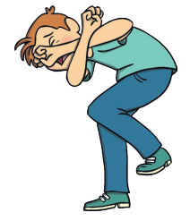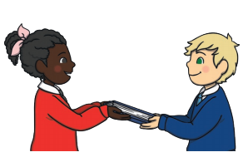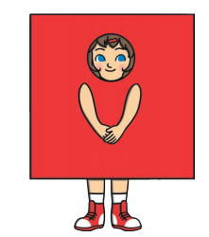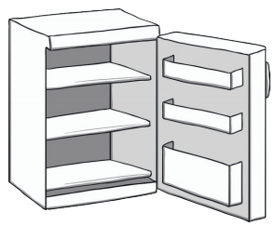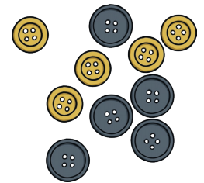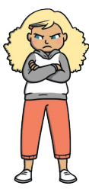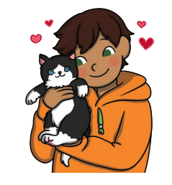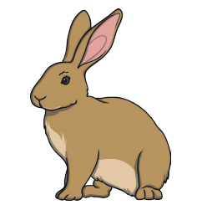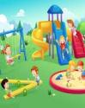

|  |  |  |  |  |  |  |
| --- | --- | --- | --- | --- | --- | --- |
|  | **Words with**  **‘are’ Sound** | Sunday | Monday | Tuesday | Wednesday | Thursday |
| 1 | hare |  |  |  |  |  |
| 2 | care |  |  |  |  |  |
| 3 | glare |  |  |  |  |  |
| 4 | bare |  |  |  |  |  |
| 5 | share |  |  |  |  |  |
| 6 | scare |  |  |  |  |  |
| 7 | spare |  |  |  |  |  |
| 8 | dare |  |  |  |  |  |
| 9 | rare |  |  |  |  |  |
| 10 | square |  |  |  |  |  |

Wednesday and Thursday write the words in alphabetical order.

**Choose 5 words and write them in a sentence: (HW 2)**

**1-______________________________________________________________________________________**

**2-_______________________________________________________________________________________**

**3-______________________________________________________________________________________**

**4-______________________________________________________________________________________**

**5-_______________________________________________________________________________________**

**Fill in the missing words**

|  |  |  |  |
| --- | --- | --- | --- |
| **square** | **scare** | **spare** | **stare** |

1. A shape with four equal sides is known as a ---------------------------.
2. I have been told not to ---------------- at the sun .
3. I want to jump out and ---------------- my little sister .
4. I have a ------------------ pencil you could borrow..