**Term1 – Week 5**

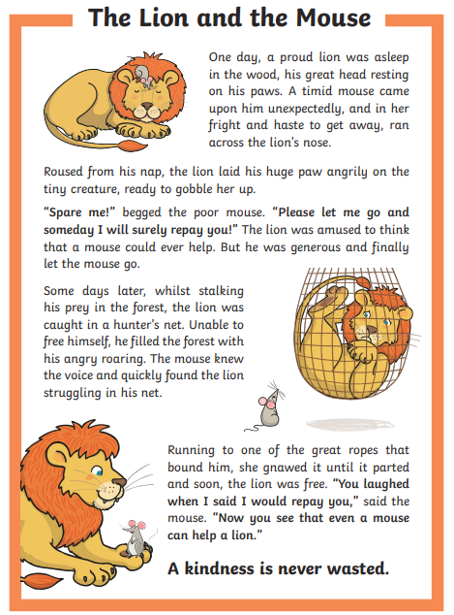

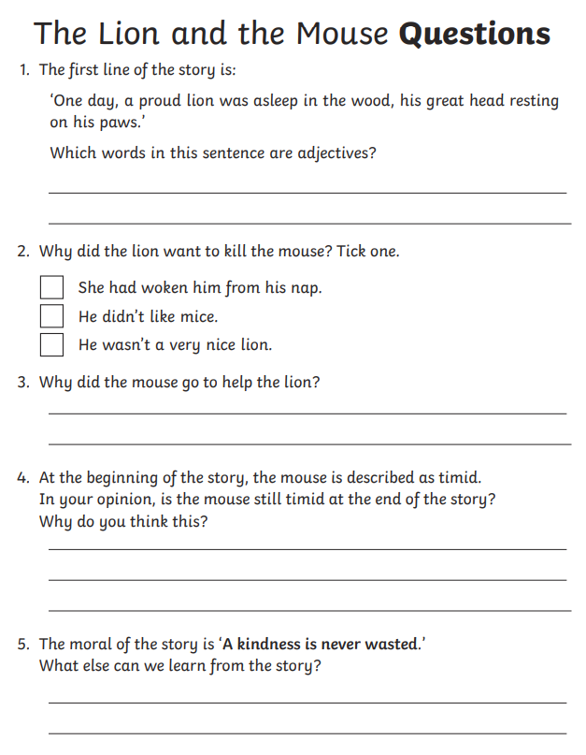

6. write a sentence with speech marks

___________________________________________________

7. find two verbs in past tense

___________________________________________________

8. find a word that means, will pay back to you

____________________________________________________

9. find a synonym of the word gigantic or enormous in the second paragraph of the text.

_________________________________

10. find an antonym for the word happily in the second paragraph in the text.

____________________________________