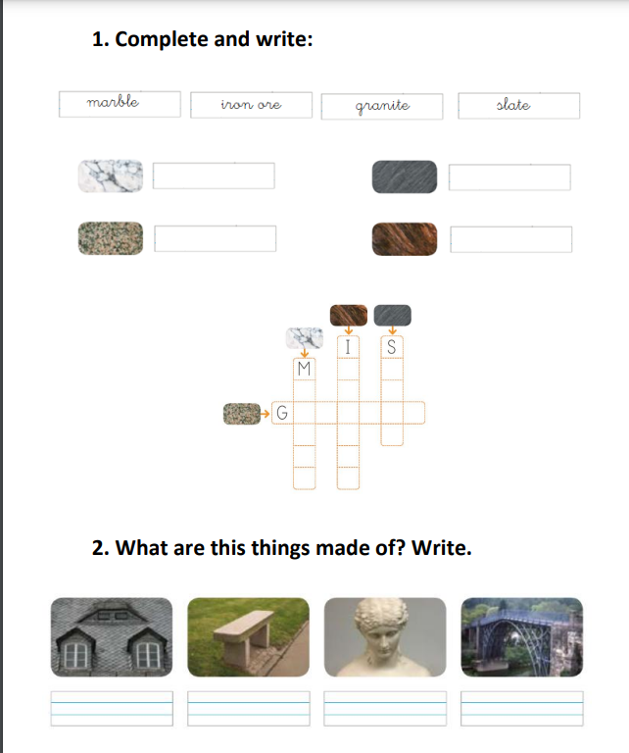

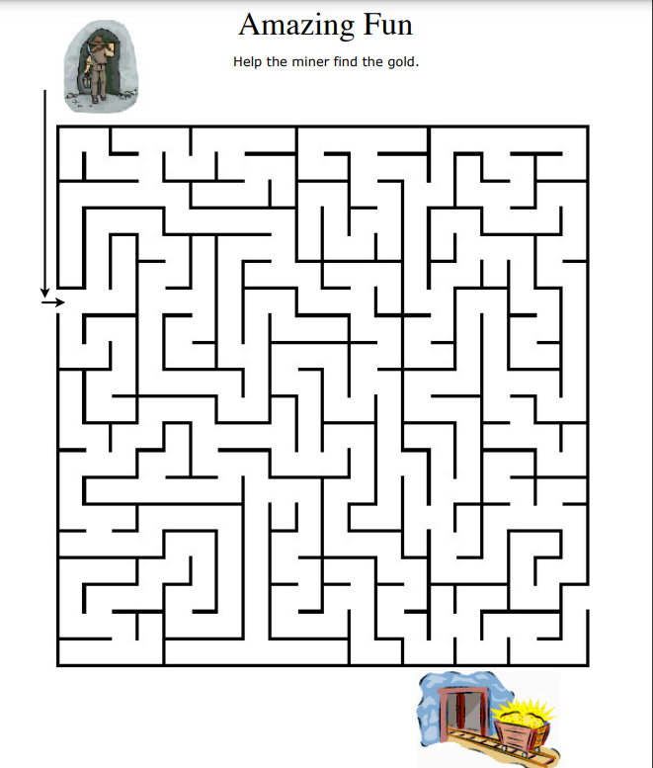

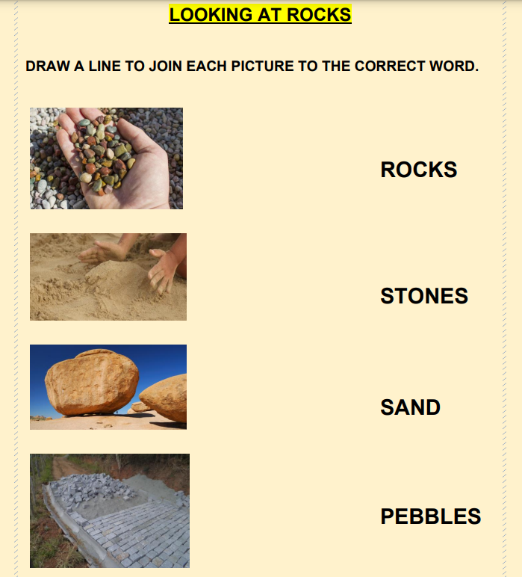

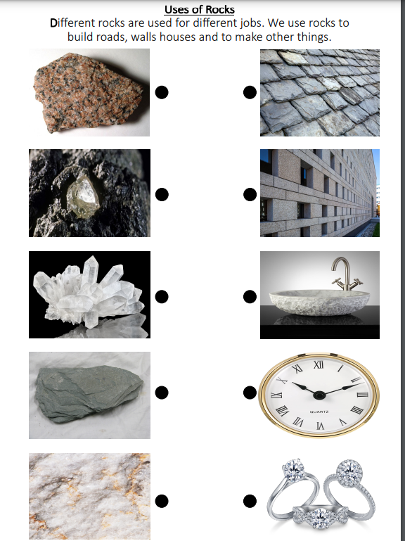

**Choose the correct answer:**

1. A deep ----------------- is the place we dig underground to find rocks or minerals.
2. mine b) iron c) habitat

1. Our planet Earth is made of --------------------.

1. water b) rocks c) flowers
2. Some rocks can ---------------- water and some can be waterproof.
3. hard b) attack c) absorb
4. ------------------ is a type of rock that can fire up.

a) Chalk b) Rocks c) Coal

1. A ---------------- is another name for a small rock.
2. stone b) chalk c) soil

