**Name: ________________________________________________________________**

**Brazil**

* **Color each country’s flag:**

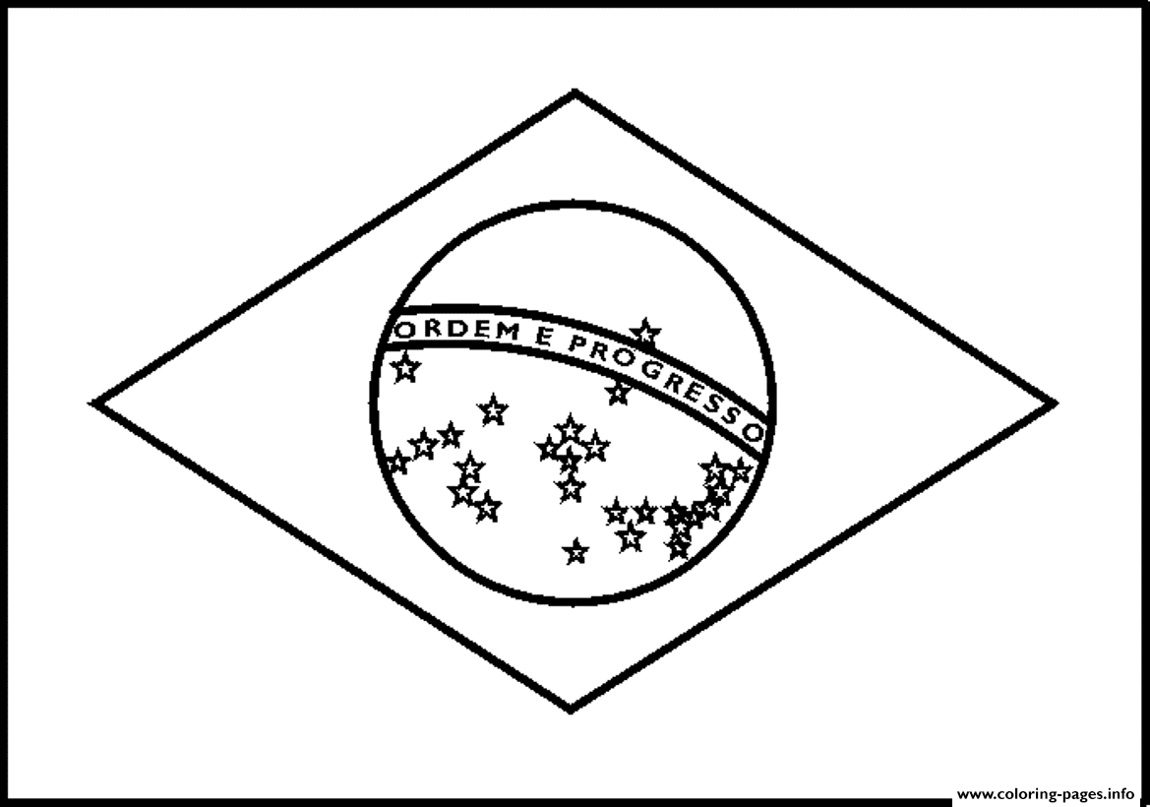

**United States**

