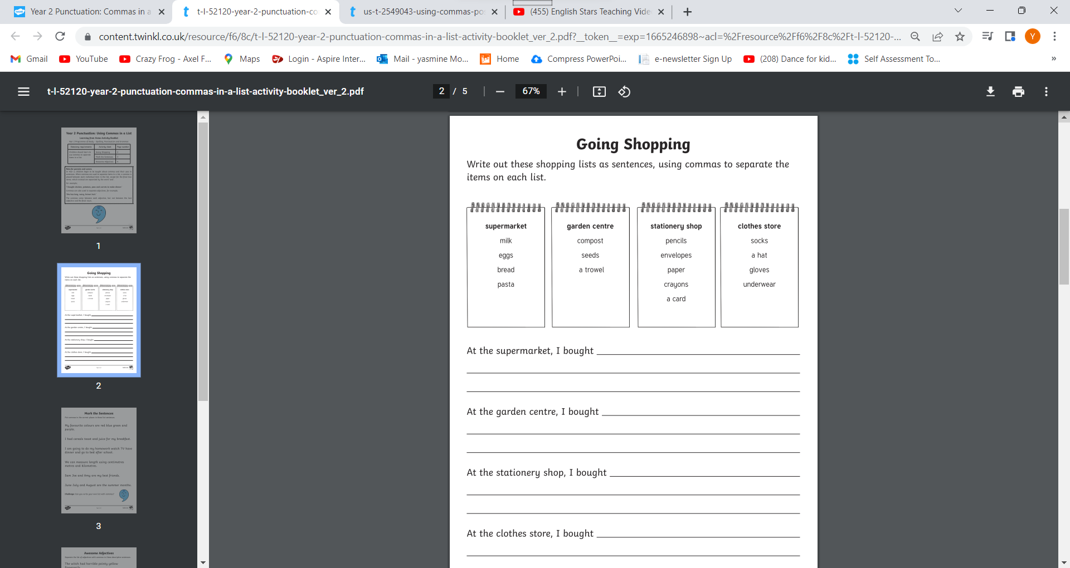LO: I can use commas to separate the items in a list. (classwork)

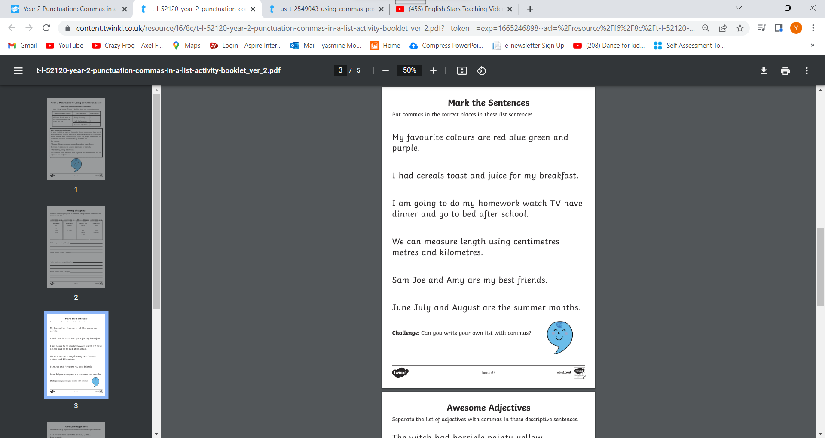LO: I can use commas to separate the items in a list. (classwork)

________________________________________________________________________________

________________________________________________________________________________

________________________________________________________________________________

________________________________________________________________________________

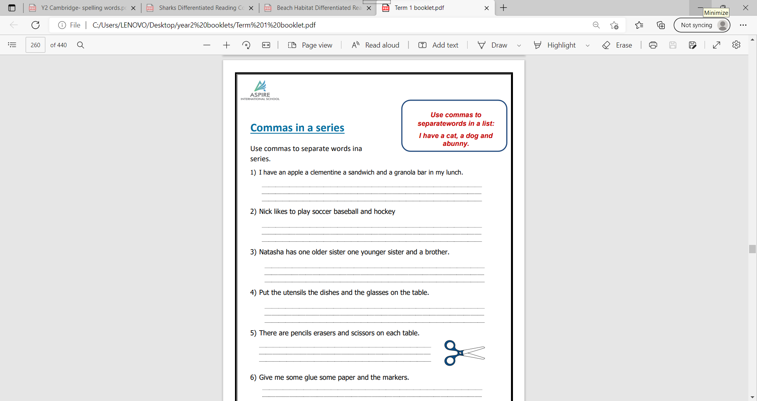LO: I can use commas to separate the items in a list. (Homework