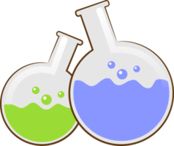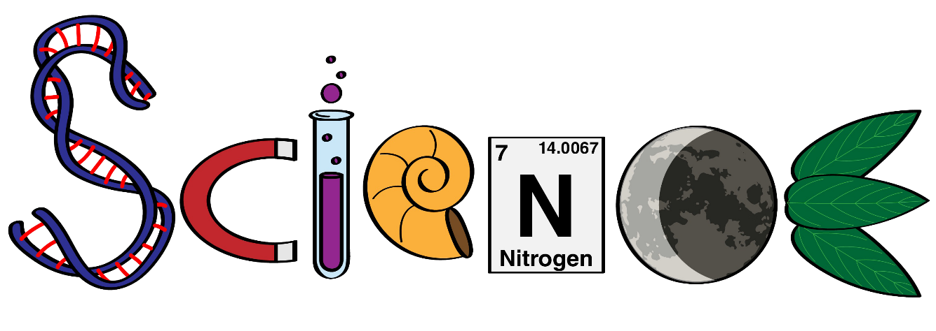

**Name: ………………………………………………….**

**Class: ……………………………………………………**

**Science Department**

**2023/2024**

**Year 2**

**Term 3, Week 3**



**Choose the correct answer:**

1. Never touch dirty or --------------------- electrical appliances. (damaged- painted)
2. Broken ---------------- can burn your skin and hurt your eyes. (windows - cells)
3. Electricity can move through ----------------. (water- wood)
4. We use electricity appliances to cool or ---------------things up.

(heat- plant)

1. Mains electricity can be ----------------------. (amazing- dangerous)
2. Cells appliances are machines that use electricity through ---------------------.

(batteries- plugs)

1. A cell is often called a ---------------------. (wire- battery)
2. Electricity moves through the --------------- part of a wire. (metal- plastic)
3. The metal should be covered by --------------- to protect you. (plastic- metal)

**Draw a circle around things in the picture that use electricity:**







