**Name: ---------------------------------**

**Class: ----------------------------------**



**Bumblebees**

*Bumblebees are insects. A bumblebee has six legs, two wings, and two antennae. They are*

*black with yellow stripes.*

*Bumblebees gather pollen and nectar from*

*flowers for food. This spreads pollen around,*

*which helps flowers, fruits, and vegetables grow.*

*Bumblebees usually build their nest on the ground*

*in very large "families." Bumblebees will defend their*

*nests. They have a very loud buzz.*

*1. Bumblebees are .*

*2. Bumblebees have yellow .*

*3. Bumblebees gather pollen and nectar for*



1. *Bumblebees have a very loud .*
2. What do Bumblebees have?
3. What happens when Bumblebees spread pollen around?
4. Bumblebees nest on trees (True/False) --------------------
5. Bumblebees have small families. (True/False) ---------------
6. Bumblebees have a very loud buzz. (True/False) -------------

Choose the correct answer.

1. Bumblebees will defend their:
2. Families
3. Food
4. Nests

Grammar

Read this sentence and find the following:

*Bumblebees usually build their nest on the ground in very large "families." Bumblebees will defend their nests.*

A Noun ---------------------------

A Verb ----------------------------

An Adjective ---------------------

Add “s” or “es” to the following words:

Bee --------------

Nest -------------

Buzz -------------

Add “ed” to the following Verbs

1. Gather ------------
2. Help ---------------
3. Defend -----------------

Vocabulary:

Write the following words into sentences:

1. Stripes: ---------------------------------------------------------------
2. Vegetables: -----------------------------------------------------------

Label the Bumblebee

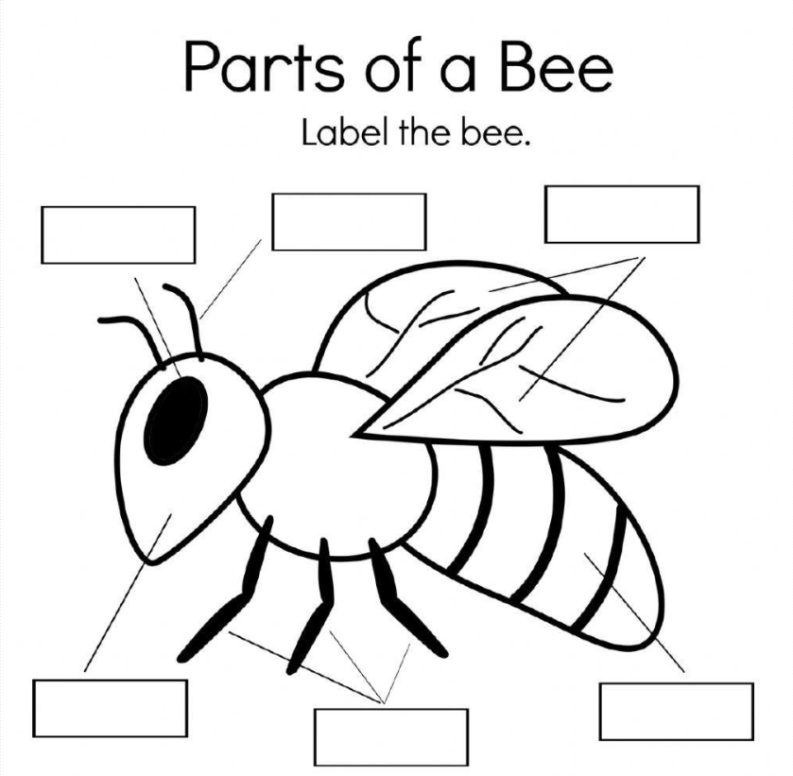

head

wings

antennae

legs

eye

body

Write 2 to 5 sentences to describe the Bumblebee.

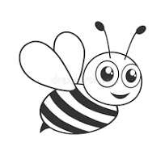

Model Answer:

1. Insects
2. Stripes
3. Food
4. Buzz
5. *A bumblebee has six legs, two wings, and two antennae.*
6. Helps flowers, fruits, and vegetables to grow.
7. False
8. False
9. True
10. Nests (C)
11. Bumblebees, ground, families, nests
12. Build, defend
13. Large
14. Bees
15. Nests
16. Buzzes
17. Gathered
18. Helped
19. Defended