

Year 2

**LO: I can identify the main features of a between non- fiction texts (Homework).**

**Bats love dark places.**

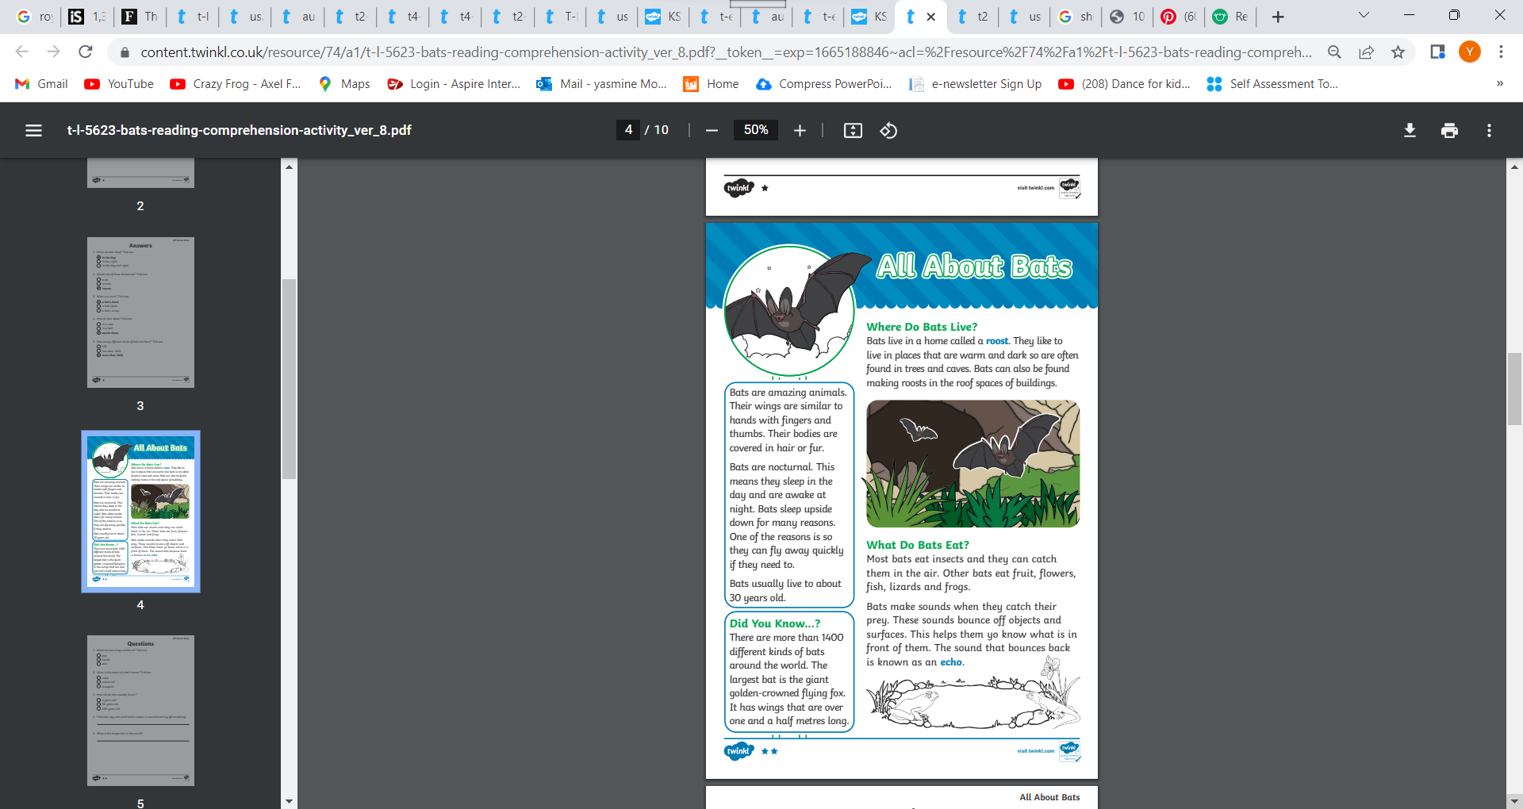

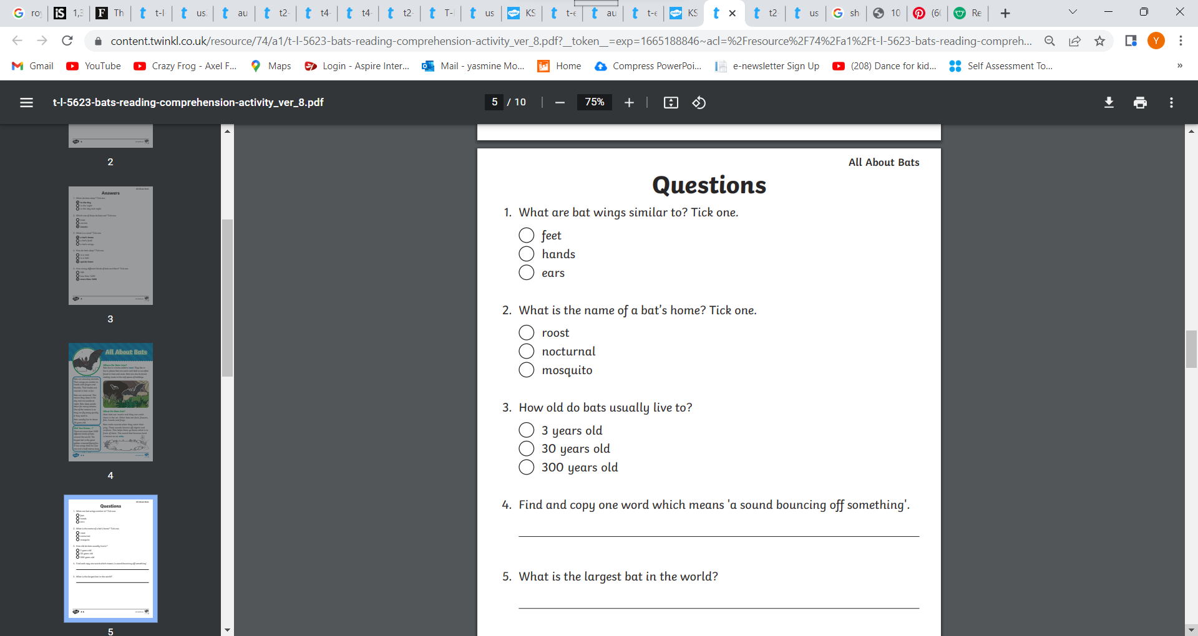

6. What is the heading in this book?

____________________________________________________

7.Can you write one sub-heading?

____________________________________________________

8.Can you find one word written in bold?

____________________________________________________

9.Can you find a caption in the text?

___________________________________________________________

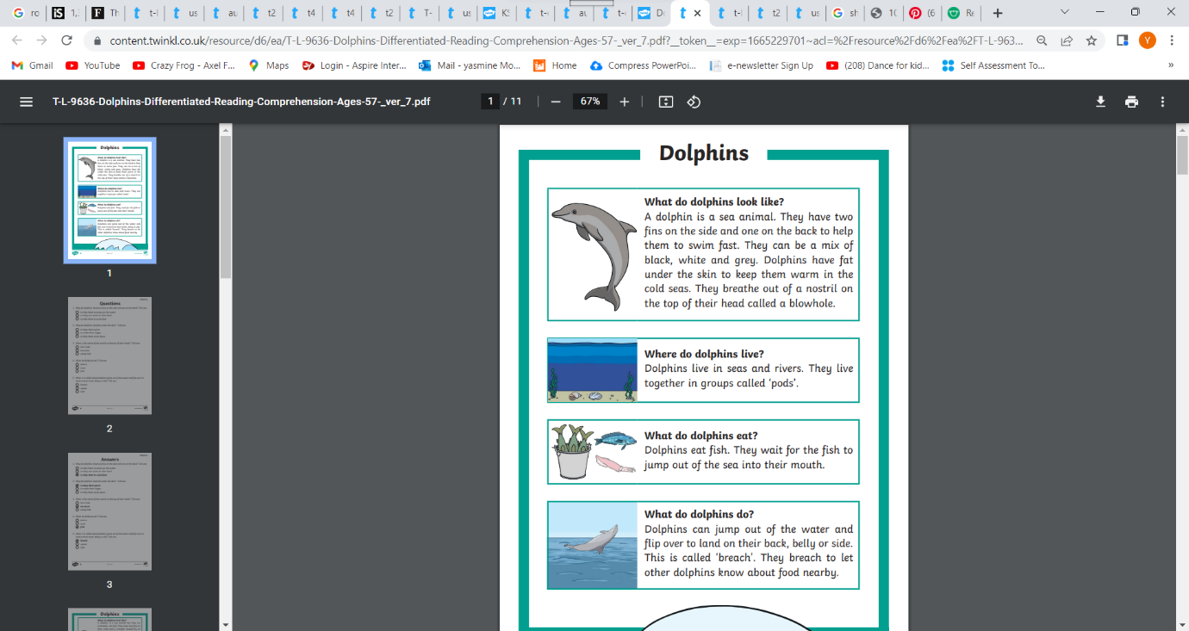LO: I can identify the main features of a non-fiction text. (Classwork)

Dolphins love people

**pods**

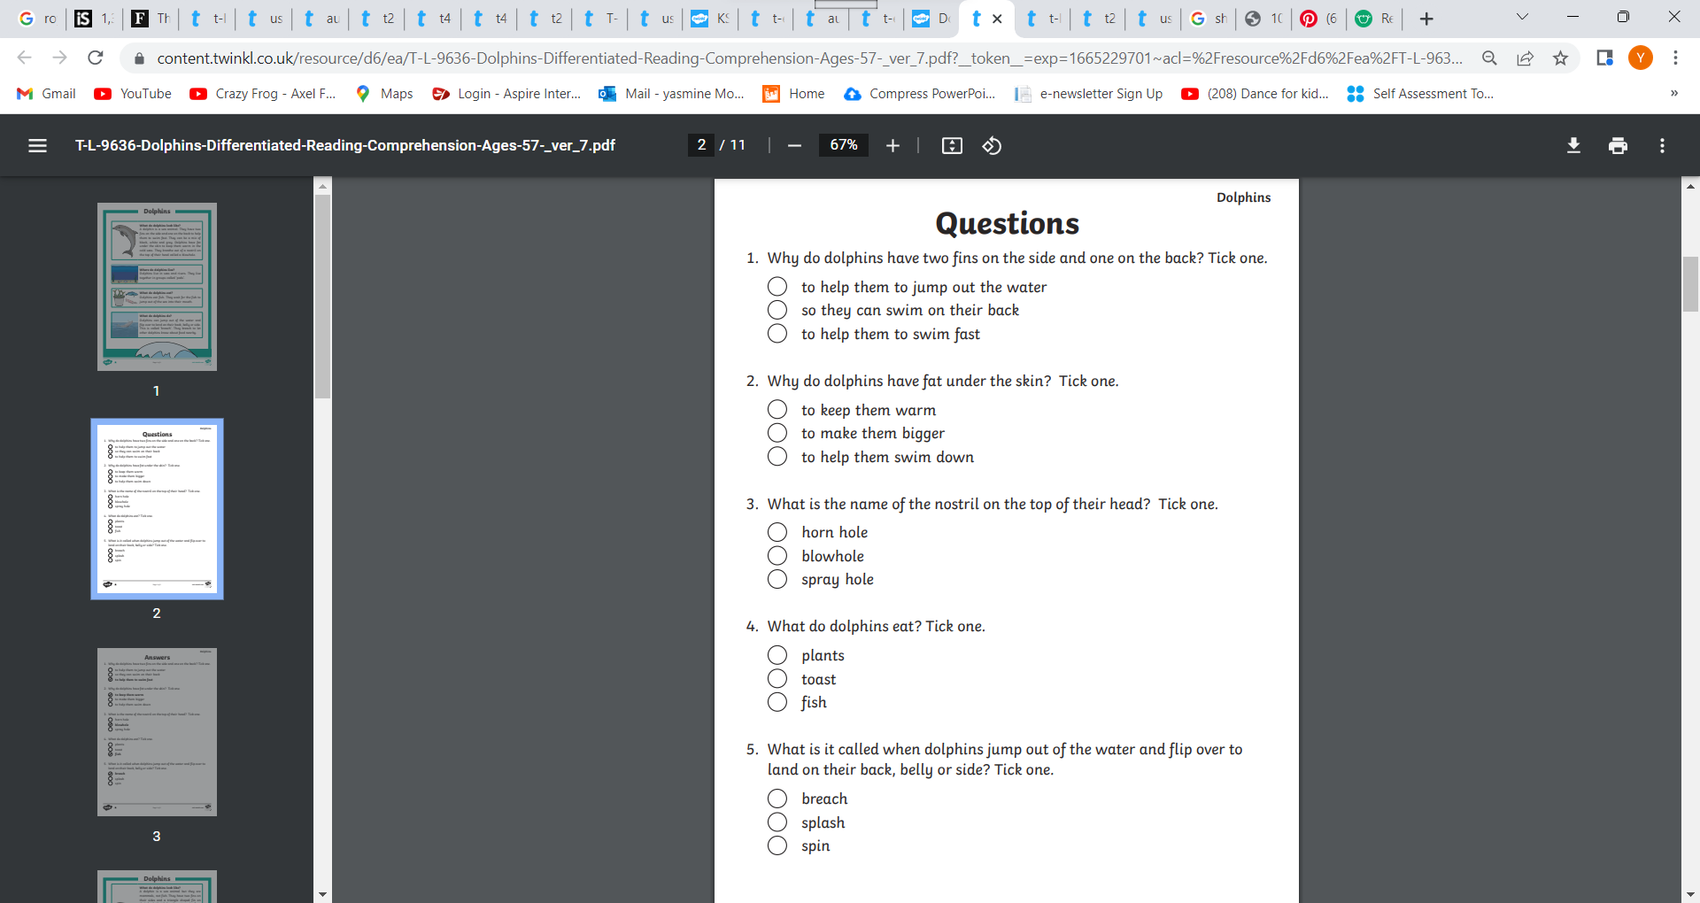

6. What is the heading in this book?

____________________________________________________

7.Can you write one sub-heading?

____________________________________________________

8.Can you find one word written in bold?

____________________________________________________

9.Can you find a caption in the text?

___________________________________________________________