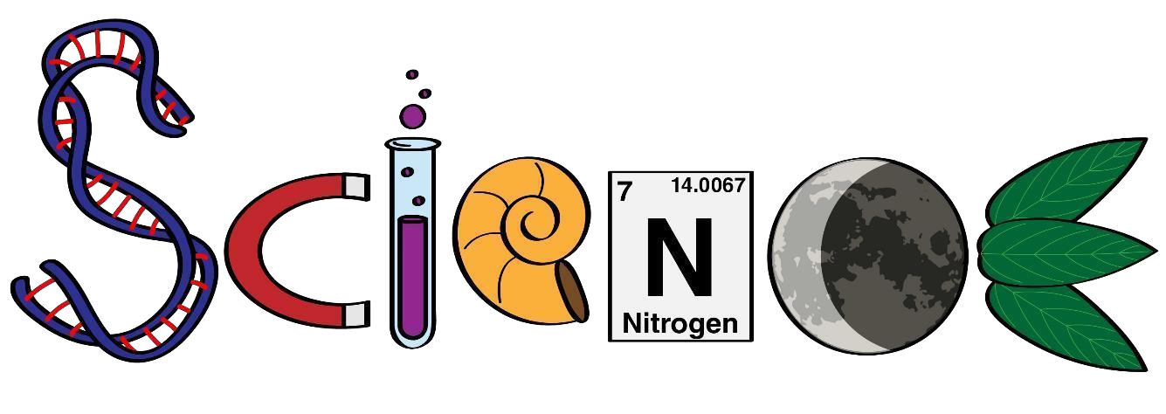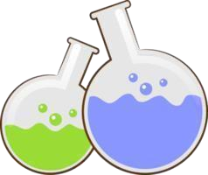

**Science Department**

**2023/2024**

**Year 4**

**Term 2, Week 1**

**Name: ………………………………………………….**

# Class: ……………………………………………………

1-Complete the following sentences by adding ‘thicker than’ or ‘thinner than’.

a The mantle is _____________________________ the crust.

b The mantle is _____________________________ the core.

2 Complete the following sentences by adding ‘hotter than’ or ‘cooler than’.

a The crust is _____________________________ the mantle.

b The core is _____________________________ the mantle.

3 Describe the difference between:

a the external structure of the Earth and the internal structure of the Earth

______________________________________________________________________________

______________________________________________________________________________

b magma and lava

______________________________________________________________________________

______________________________________________________________________________

c an earthquake and a tsunami.

______________________________________________________________________________

______________________________________________________________________________

**2- Color, label, and describe each layer below.**

