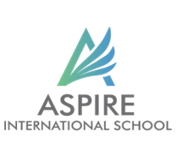Year 8

Name:________________________ Date: ___________________

Answer the following general questions :

1. How does the character of Ebenezer Scrooge evolve throughout the novella, and what factors contribute to his transformation?

2. Discuss the role of the three spirits in "A Christmas Carol." How do they influence Scrooge's journey of redemption?

3. What themes are prevalent in "A Christmas Carol," and how are they explored throughout the novella?

4. How does Charles Dickens use symbolism, such as the ghostly visitors and the setting of Victorian London, to convey deeper meanings in the story?

5. Reflect on the significance of the title, "A Christmas Carol." What does the term "carol" represent, and how does it relate to the themes and messages of the novella?