Write the following vocabulary words in sentences
Activity 1

camouflage | scaly
Curly tail | pouch
Match the word to the correct meaning

Word | Meaning
curly tail | The pocket of skin on an animals stomach in which its baby grows.
pouch | Some animals are coloured and shaped so that they cannot be seen by their enemies
camouflage | Small pieces of hard skin  covering an animal’s body
scaly | Curved in shape.

Match the picture to the correct meaning.

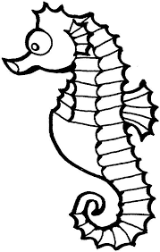 | The pocket of skin on an animals stomach in which its baby grows.
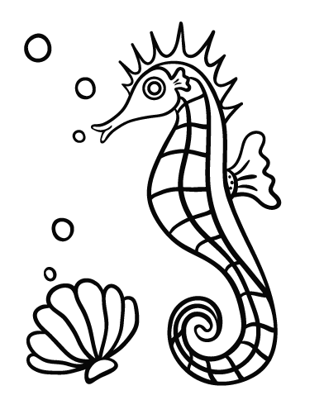 | Some animals are coloured and shaped so that they cannot be seen by their enemies
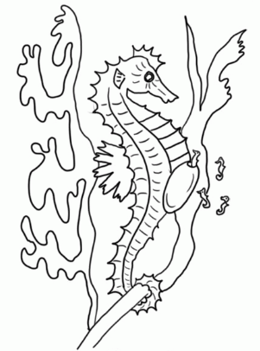 | Small pieces of hard skin  covering an animal’s body
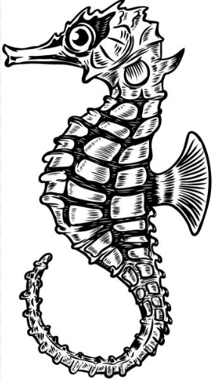 | Curved in shape.

Match the picture to the correct vocabulary word.

Pouch
Curly tail
Camouflage

Scaly.

