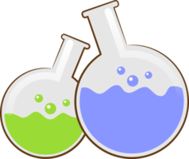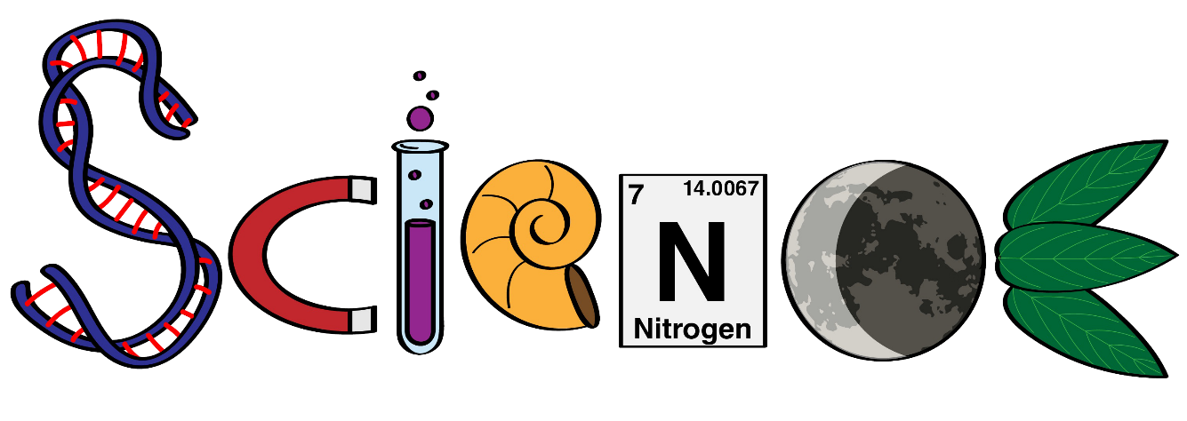

**Name: ………………………………………………….**

**Class: ……………………………………………………**

**Science Department**

**2023/2024**

**Year 2**

**Term 1, Week 7**



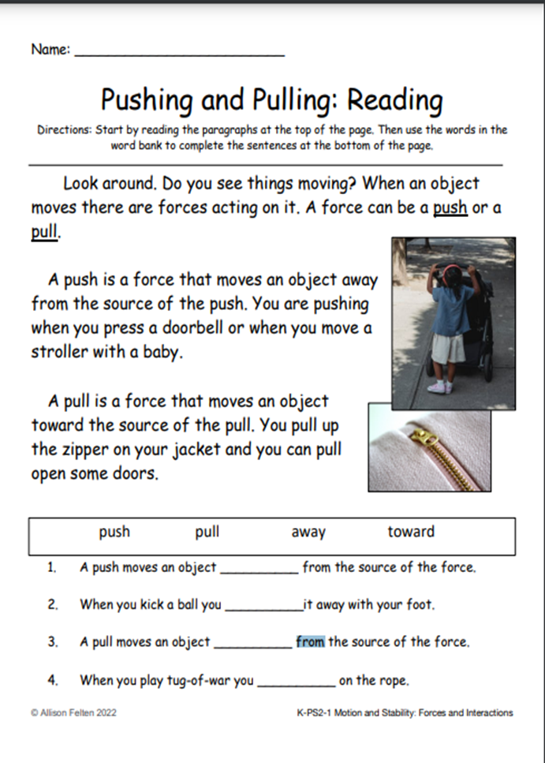

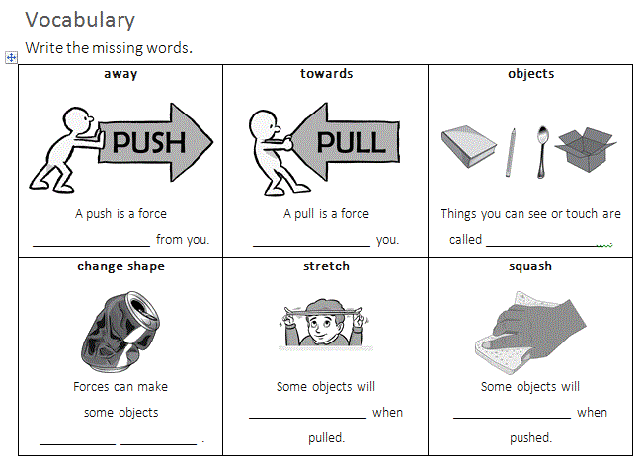

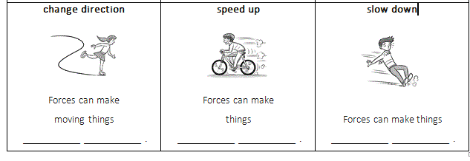

**Choose the correct answer:**

1. Forces can make things -------------- or stop. (move- fall)
2. We need ------------- force to push a gigantic rock. (small- big)
3. A ------------- force is used to push the ball. (small- big)
4. A pull is a force -------------------------. (away from you- towards you)
5. I -------------- my kite so it won’t fly away.

**Write the correct force next to each picture, push or pull:**

