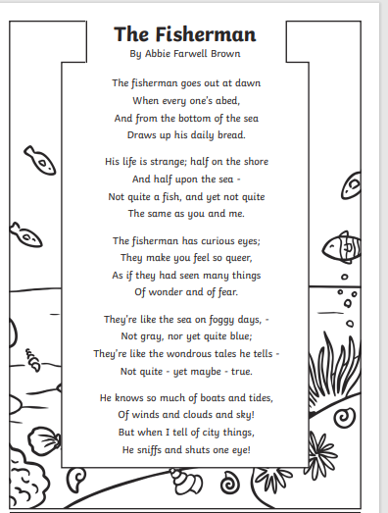

A) Who is the poet?

_____________________________________________________

B) What is the title?

_____________________________________________________

C) Find a repetition word or phrase

_____________________________________________________

D) How many lines in the poem?

_____________________________________________________

E) How many stanzas in the poem?

_____________________________________________________

F) In the fourth stanza, there is an alliteration?

_____________________________________________________

G) Can you write four rhyming words?

_____________________________________________________

H) what is the poem about?

_____________________________________________________

I) In the third stanza, find a synonym for “want to know everything”

_____________________________________________________

J) In the first stanza, find an antonym for “top”

_____________________________________________________

K) Write the rhyming scheme for this poem?

_____________________________________________________