Spelling Words Term1 – Week 10

Term1 – Week 5

 | Words ending in el | Sunday | Monday | Tuesday | Wednesday | Thursday
1 | squirrel
2 |   Kennel
3 | level
4 |   panel
5 |   gravel
6 |   parcel
7 | tunnel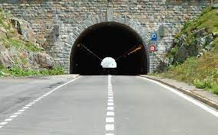
8 | quarrel
9 | flannel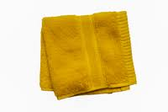
10 | travel

Choose 5 words and write them in a sentence:

1-______________________________________________________________________________________

2-_______________________________________________________________________________________

3-______________________________________________________________________________________

4-______________________________________________________________________________________

5-_______________________________________________________________________________________

-copy and complete the sentences using the words in the box.
Squirrel-towel-cancel-hotel-caramel
1-I love eating chocolate cake with _______________
2-I saw a _______________ on the tree.
3-I would rather stay in a ______________ than rent a house.
4-My mum gives me a _______________ to wipe my face.
5-The school has to _______________ the trip because of the bad weather.

Bonus Words

saw
ate

