Spelling Words Term1 – Term 2/week 1

Term1 – Week 5

 | Words ending in-il | Sunday | Monday | Tuesday | Wednesday | Thursday
1 | pupil
2 | Basil  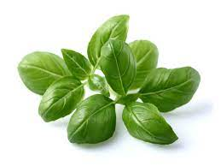
3 | Stencil  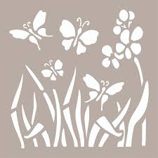
4 | Council  
5 | Gerbil  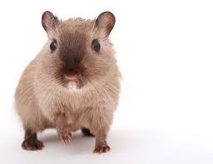
6 | until
7 | Tonsil  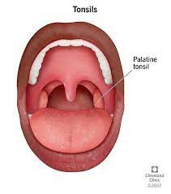
8 | Fossil  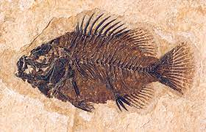
9 | brazil
10 | evil
11 | daffodil
12 | Lentil  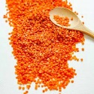

1.Which word is spelled correctly?
a. evill
b. counsil
c. lentel
d. evil

2. What is the opposite of evil?
a. good
b. bad
c. kind
d. nice

3. What is the name of a type of flower mentioned in the topic?
a. rose
b. daffodil
c. tulip
d. lily

4. Complete the sentence: "I am a _ _________________of the second-grade class."
a. pupil
b. student
c. teacher
d. parent

5. Which word is spelled correctly?
a. bresil
b. dreasil
c. brazil
d. brazier

6. What is the synonym of evil?
a. carrot
b. kind
c. devil
d. good

7. Which word is spelled correctly?
a. councel
b. counsel
c. cunsell
d. council

8. What is another word for a student?
a. teacher
b. pupil
c. principal
d. librarian

9. What is the name of a country mentioned in the topic?
a. Egypt
b. Brazil
c. France
d. Australia

10. What is the name of a vegetable mentioned in the topic?
a. cabbage
b. carrot
c. potato
d. lentil

