Different houses

Carvan- a vehicle equipped for living in, typically towed by a car

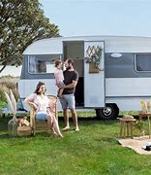

Apartments(flats)- An apartment is a building where people pay the owner money to live there

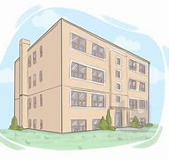

Cottage - a small house, typically one in the country

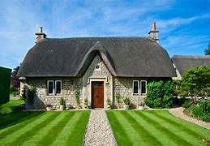

Stilt-houses - Stilt houses are houses built on elevated platforms

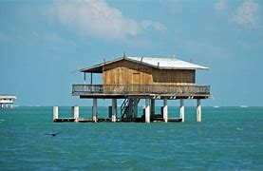

Terrace- A row or terraced house is a house that is part of a row of houses joined at the side walls.

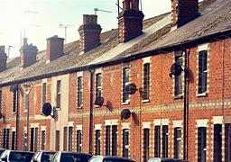

Chalet - a house common in the Swiss Alps, having balconies, and wide eaves. a villa or lodge built in this style

