

English



Weekly Pack

Year 2/Term 2

Week 11

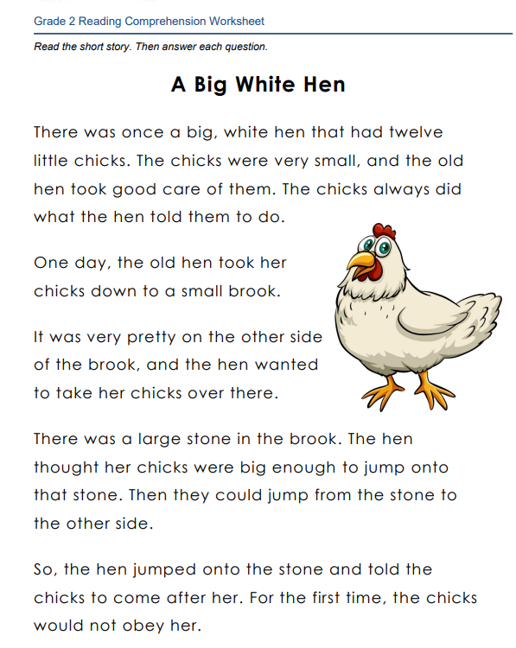

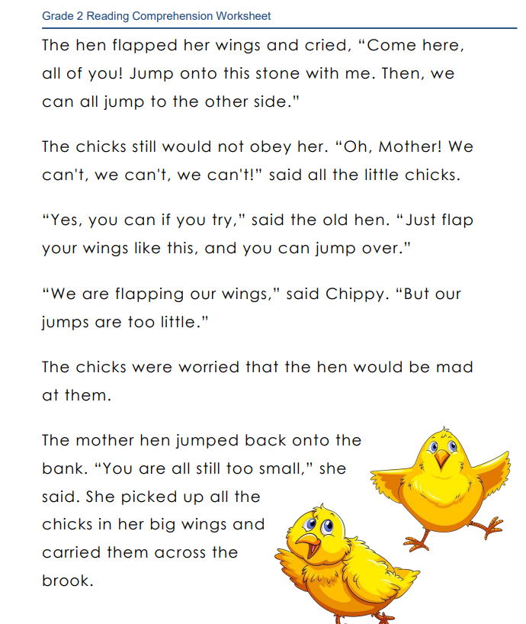

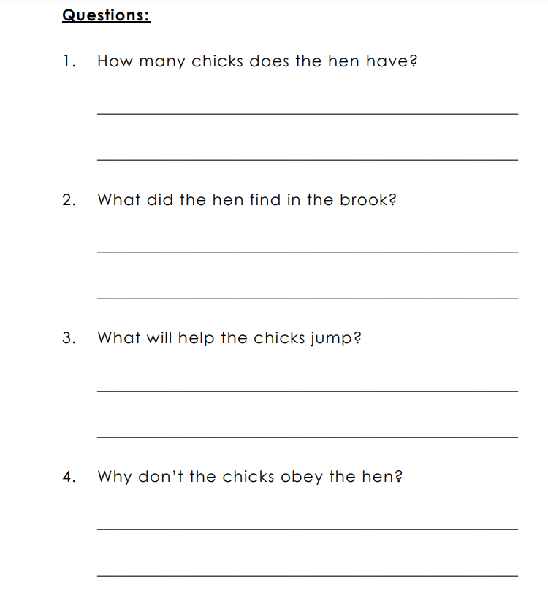 5. What did the old hen have besides herself at the beginning of the story?

___________________________________________________

1. How many little chicks did the old hen have?

______________________________________________

1. Where did the old hen take her chicks one day?

_____________________________________________

1. Why did the old hen want her chicks to jump onto a large stone in the brook?

______________________________________________

1. Why did the chicks refuse to obey the hen for the first time?

_____________________________________________

1. How did the chicks respond to the hen's encouragement to jump over to the other side of the brook?

_____________________________________________

1. How did the old hen finally get her chicks across the brook?

_____________________________________________

12.What does "flapped" mean in the context of the story?

___________________________________________________

1. Based on the text, how would you define the word "obey"?

____________________________________________

1. In your own words, explain the meaning of the word "picked up" as used in the story?

_____________________________________________

1. **Find from the text:**

**Noun: ___________________**

**Adjective: _______________**

**Adverb: ________________**

**Past tense: ______________**

**Suffixes: ________________**

**A sentence with exclamation marks: ____________________________________________**

**A sentence with speech marks: ____________________________________________**

**A Synonym for the word “crazy”:**

**__________________________________**

**An antonym for the word “calm”:**

**__________________________________**