Spelling Words Term1 – Term 2/week 1

Term1 – Week 5

 | Words ending in-il | Sunday | Monday | Tuesday | Wednesday | Thursday
1 | pupil
2 | Basil  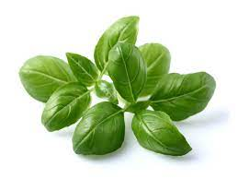
3 | Stencil  
4 | Council  
5 | Gerbil  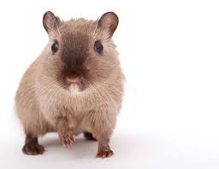
6 | until
7 | Tonsil  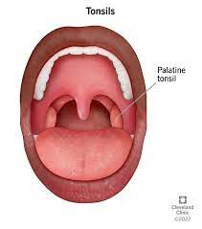
8 | Fossil  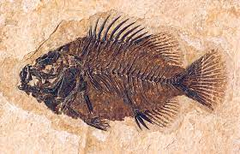
9 | brazil
10 | evil
11 | daffodil
12 | Lentil  

1.Which word is spelled correctly?
a. evill
b. counsil
c. lentel
d. evil

2. What is the opposite of evil?
a. good
b. bad
c. kind
d. nice

3. What is the name of a type of flower mentioned in the topic?
a. rose
b. daffodil
c. tulip
d. lily

4. Complete the sentence: "I am a _ _________________of the second-grade class."
a. pupil
b. student
c. teacher
d. parent

5. Which word is spelled correctly?
a. bresil
b. dreasil
c. brazil
d. brazier

6. What is the synonym of evil?
a. carrot
b. kind
c. devil
d. good

7. Which word is spelled correctly?
a. councel
b. counsel
c. cunsell
d. council

8. What is another word for a student?
a. teacher
b. pupil
c. principal
d. librarian

9. What is the name of a country mentioned in the topic?
a. Egypt
b. Brazil
c. France
d. Australia

10. What is the name of a vegetable mentioned in the topic?
a. cabbage
b. carrot
c. potato
d. lentil

LO: I can write about my holiday

Sunday, 8th January 2024

Remember to use:

1-Punctuations (capital letter, finger spaces and full stops)

2-adjectives

3-connectives

Read the text and highlight the main vocabulary words

In a classroom filled with laughter and excitement, Jenny poked her classmate gently in the arm. "I have something to share with you," she whispered. The students gathered around her, their eyes shining with curiosity. Jenny scuttled to the front of the room and grabbed the whiteboard eraser. With a big smile, she scrubbed away the colorful drawings, leaving the board clean and ready for a new adventure. The children shivered with anticipation, wondering what surprise Jenny had in store. As Jenny began to speak, her words were filled with kindness and compassion. "Today, we will learn about the power of kindness," she said. "Kindness is like a warm blanket that wraps around us, making us feel safe and loved. It is the key to building strong friendships." The children listened intently; their hearts touched by Jenny's words. They knew that kindness was not just a word, but a way of life. They understood that being resilient meant bouncing back from challenges with a positive attitude and a willingness to help others. And as the class embarked on their journey of kindness, they discovered that when you share a smile, a helping hand, or a kind word, you create a ripple effect that spreads joy and happiness to everyone around you. With each act of kindness, the world becomes a better place. The power of kindness is in your hands. So, remember, be kind, be empathetic, and watch as the world transforms before your eyes.

1. What does the word "poked" mean?
a. to hide
b. to jump
c. to hit gently
d. to run

2. What does the word "scuttled" mean?
a. to crawl quickly
b. to fly high
c. to sleep deeply
d. to swim slowly

3. What does the word "shiver" mean?
a. to smile brightly
b. to laugh loudly
c. to cry quietly
d. to tremble from cold or fear

4. What does the word "scrubbed" mean?
a. to cook food
b. to break an object
c. to clean something
d. to build a structure

5. What does the word "resilient" mean?
a. to take a nap
b. to exercise in the morning
c. to recover quickly from difficulties
d. to eat a lot of food

6. What does the word "share" mean?
a. to keep for oneself
b. to give to others
c. to throw away
d. to hide from others

