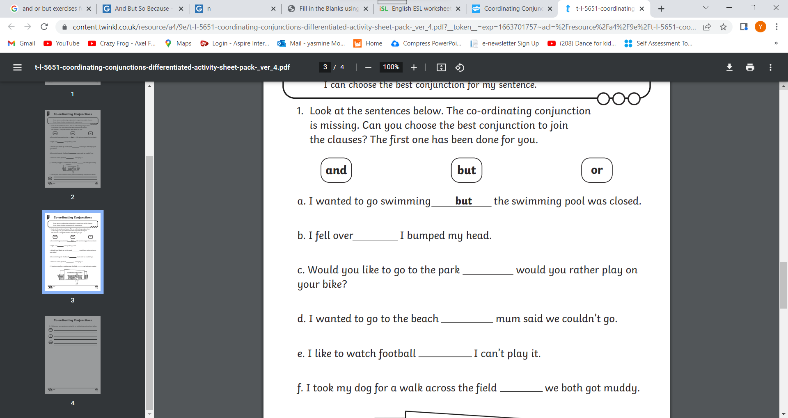LO: I can use the right conjunction to identify the meaning of the sentence (Homework)

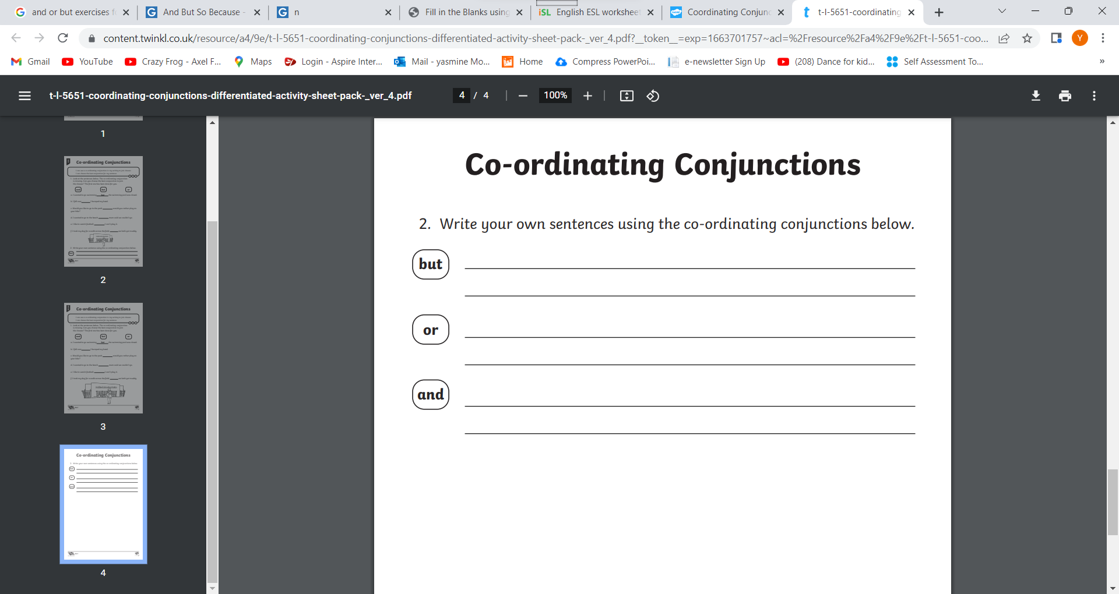

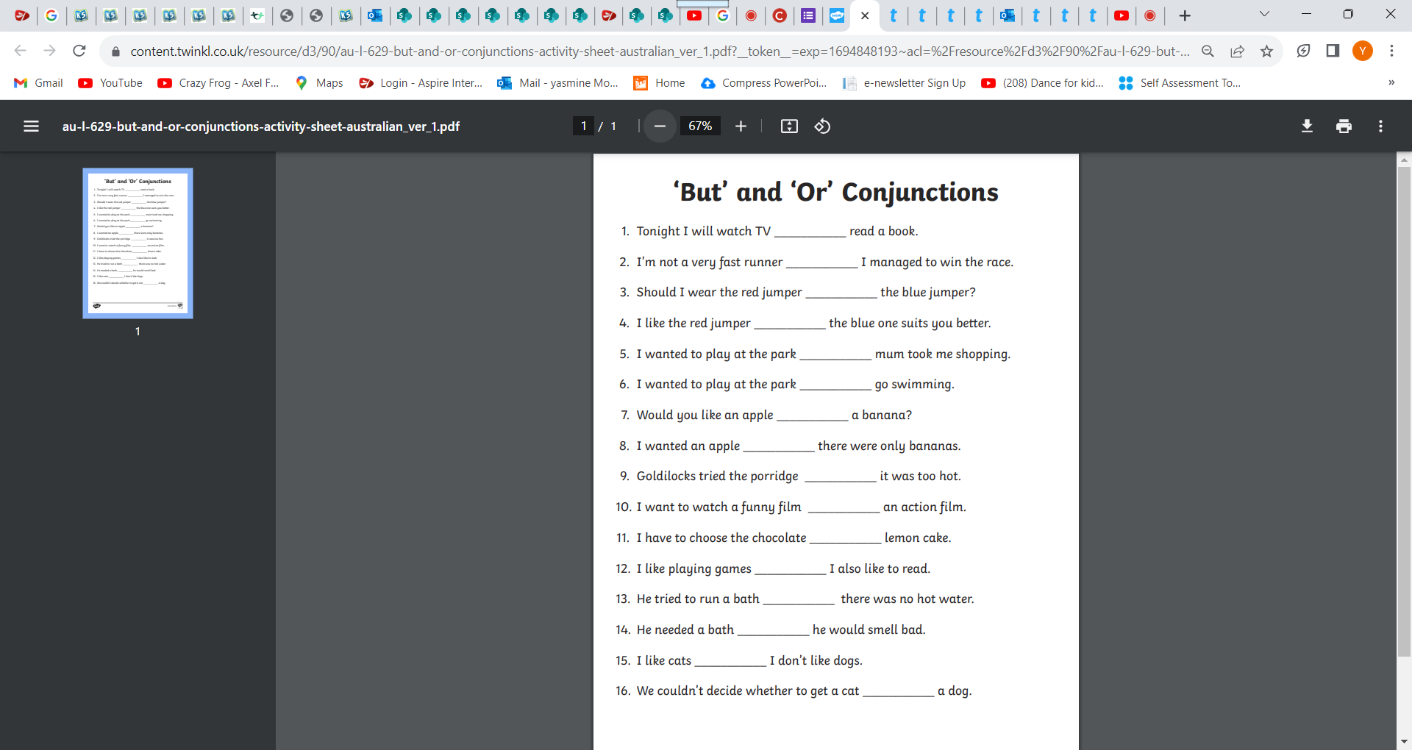

**and but or**

LO: I can use my conjunctions to identify the meaning of the sentence

Fill in the missing word.

1. My name is Mariam _______ my sister’s name is Fatima.
2. I’m 22 years old ________ my birthday is on Tuesday.
3. I was born in Dubai ______ I live in Al Ain now.
4. My mother was born in Oman ______ she lives in The UAE now.
5. I’m a doctor ______ I work in a hospital ______ I don’t like my job.
6. My father is a police officer ______ he works at the police station.
7. My older sister works in a school _______ she likes it.
8. I don’t eat fish, beef _____ chicken.
9. My family travels to Oman _______ Saudi Arabia ______ they don’t travel to Yemen ______ Qatar.
10. I’m married ______ I live with my husband _____ our three kids.
11. I don’t speak German _____ French _____ I speak a little Spanish.
12. I have one son _____ two daughters ______ sister doesn’t have any children.

