**Revision Pack**

**Vocabulary:**

**Brave: Courage Wicked: Evil Clever: Smart**

**Cunning: Sly**

|  |  |  |  |
| --- | --- | --- | --- |
| **brave** | **wicked** | **clever** | **cunning** |

The wicked and cunning fox, he ran after the

brave, and smart pig to eat it.

**Elated: Excited Awful:Dreadful Proud: Pleased**

**Terrible: Bad**

|  |  |  |  |
| --- | --- | --- | --- |
| **elated** | **awful** | **proud** | **terrible** |

Sarah was elated to go to the trip. She was proud

of her good marks. She felt awful, and terrible

for not taking her best friend with her.

**Claws: Sharp curved nails on some birds and animals.**

**Fierce: angry**

**Jaws: Two bones which teeth are attached to.**

**Fur: Thick soft hair that grows on some animals (mammals)**

|  |  |  |  |
| --- | --- | --- | --- |
| **claws** | **fierce** | **jaws** | **fur** |

Tigers are known for their fierce nature.

They have fur that is orange with black stripes.

Tigers have sharp claws and powerful jaws

which they use to catch other animals to eat.

**Match the word to its correct meaning**

**Cunning smart**

**Clever evil**

**Wicked courage**

**Brave sly**

**Choose the correct answer**

1. There is an **awful** smell in the classroom

Awful means:

1. Good
2. Dreaful
3. I am **elated** for getting a new car.

Elated means

1. Excited
2. Sad
3. Last night I had a **terrible** dream.

Terrible means

1. Great
2. Bad

**Match the picture to the meaning**

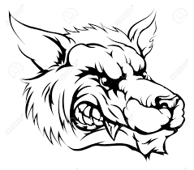

Thick soft hair that grows on mammals.

fierce

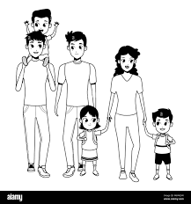

The sharp curved nails of some animals and birds.

offspring

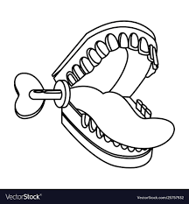

A person’s children or an animal’s young.

jaws

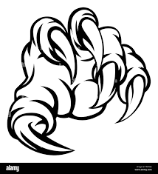

angry

claw

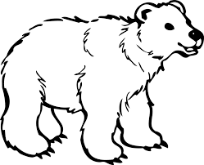

Two bones which teeth are attached to.

fur