**Name: ________________________________________________________________**

**Italy**

* **Color each country’s flag:**

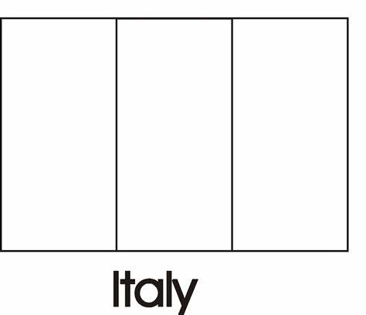

**Egypt**

