

English

Weekly Pack

Year 2-Week 11



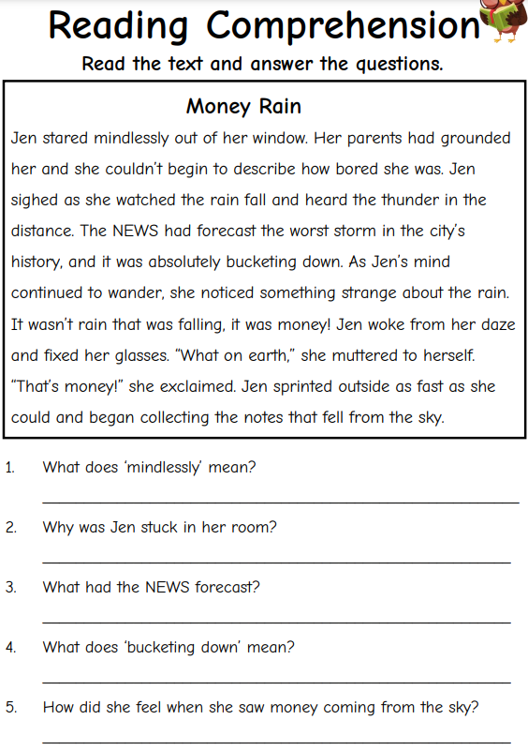

**Work bank**

1-mindlessly:

Couldn’t think

2-grounded:

punished

3-daze:

dizzy

4-bucketting down:

Rain heavily

Find from the text a word that means punished.

__________________________________

7.If you were Jen, what would you do?

_______________________________________

8.How was Jen’s feeling at the end of the text?

_______________________________________

9. Find a past tense verb from the text and change it into present tense.

_______________ __________________

10-Find a synonym for the word” weird”

__________________

11-Find an antonym for the word “rewarded”

__________________

