1. What does the digit 5 represent in the number 56789?
2. What does the digit 6 represent in the number 56789?

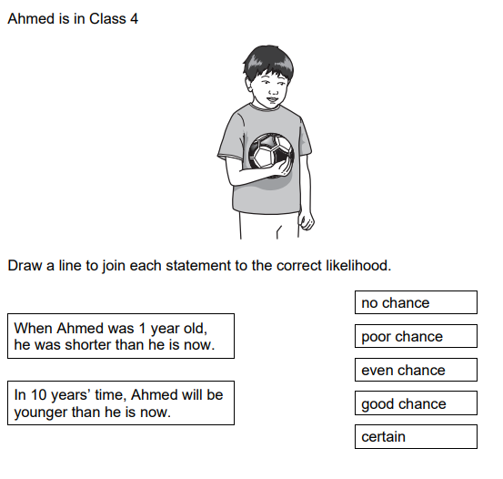

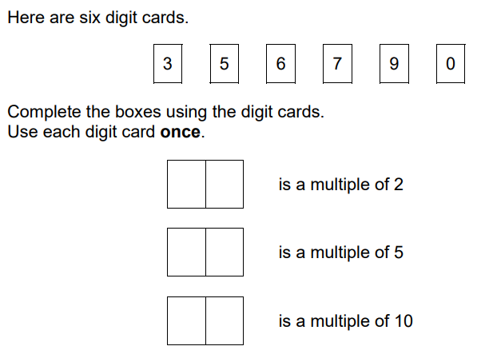

**5)**

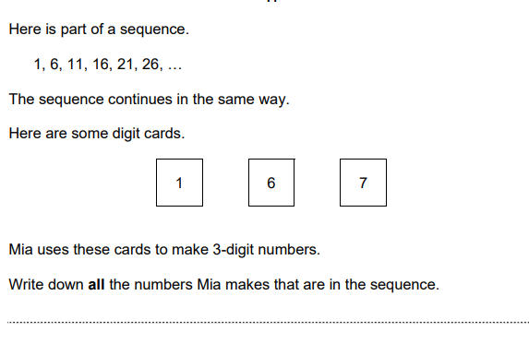

**6)**

Write the missing numbers in this multiplication grid

|  |  |  |  |
| --- | --- | --- | --- |
| x |  | **6** | **4** |
| **10** | **20** |  |  |
| **5** |  |  |  |
|  | **18** |  |  |

**7)**

Lara thinks of a whole number between 1 and 10.

The table shows information about her number

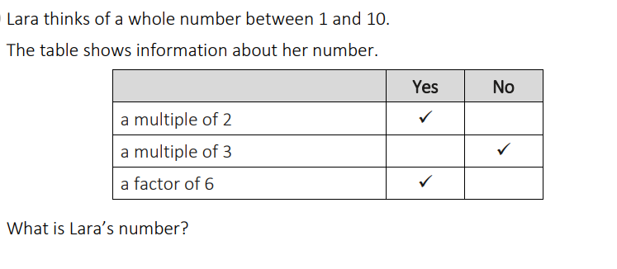

8) Write in words the smallest number that you can make using the digits

**5 , 1 , 3 , 4**

9) Erik makes a sequence of numbers.

His term-to-term rule is to add the same amount each time.

Write the missing numbers

3 , ………….., ………….., 15

10) What are the factors of 14?

11) What are the factors of 27?

12)

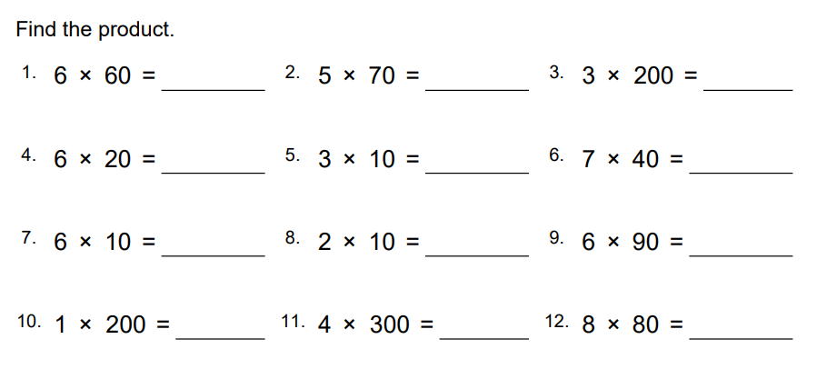

**13)**

