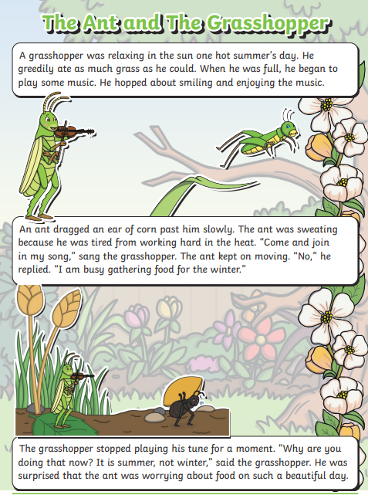

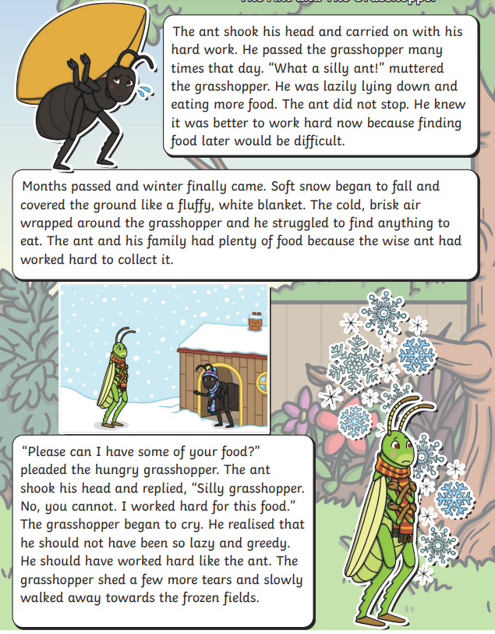

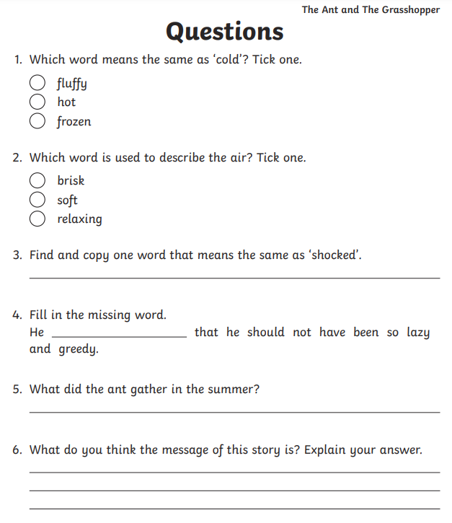

7. Write a sentence with speech marks

________________________________________________

8. Find an adverb

9. Find a verb in past tense

__________________________________________________