Spelling Words
Term1 – Week 4
 | Words ending in (-ge) | Sunday | Monday | Tuesday | Wednesday | Thursday
1 | page
2 |   rage
3 | strange
4 | 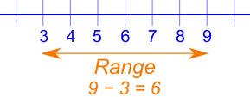  range
5 | 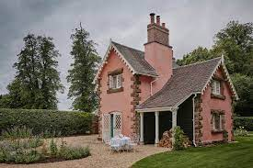  cottage
6 | large
7 | barge 
8 | change
9 | charge
10 | message

Choose 4 words from your spelling words and write them down in a sentence:

- _____________________________________________________

- _____________________________________________________

- _____________________________________________________

- _____________________________________________________

Can you think of any other words that have -ge sound?

1-____________________ 2-____________________

3-____________________ 4- ____________________
Bonus Words:

thought
through

