**Spelling Words Term 2 – Week 4 (HW 1)**

**Term1 – Week 5**

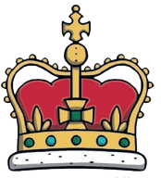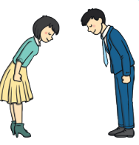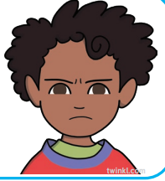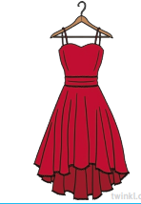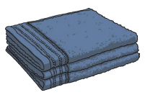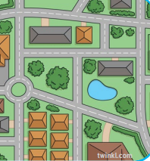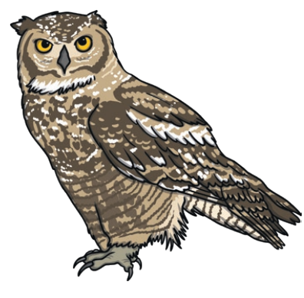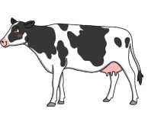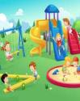

|  |  |  |  |  |  |  |
| --- | --- | --- | --- | --- | --- | --- |
|  | **Words with**  **Ow Sound** | Sunday | Monday | Tuesday | Wednesday | Thursday |
| 1 | owl |  |  |  |  |  |
| 2 | cow |  |  |  |  |  |
| 3 | crown |  |  |  |  |  |
| 4 | brown |  |  |  |  |  |
| 5 | town |  |  |  |  |  |
| 6 | clown |  |  |  |  |  |
| 7 | towel |  |  |  |  |  |
| 8 | gown |  |  |  |  |  |
| 9 | frown |  |  |  |  |  |
| 10 | bow |  |  |  |  |  |

Wednesday and Thursday write the words in alphabetical order.

**Choose 5 words and write them in a sentence: (HW 2)**

**1-______________________________________________________________________________________**

**2-_______________________________________________________________________________________**

**3-______________________________________________________________________________________**

**4-______________________________________________________________________________________**

**5-_______________________________________________________________________________________**

**Fill in the missing words**

|  |  |  |  |  |
| --- | --- | --- | --- | --- |
| **crowns** | **towel** | **owl** | **brown** | **cows** |

1. On the farm there are chickens, sheep, pigs, and --------------.
2. After my shower I dry myself with a soft -------------------.
3. The ---------------is a very smart bird.
4. The king and queen have gold and silver --------------------.
5. Chocolate is a dark ------------------ colour.