**LO: I can match the words to the meanings of my new words (HW)**

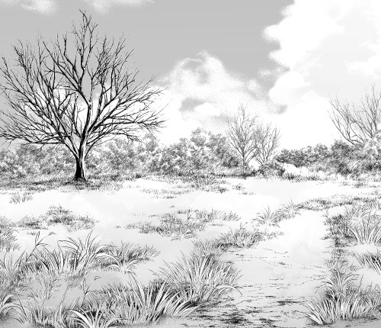

A large, flat area of land covered with grass, usually with few trees

**grassland**

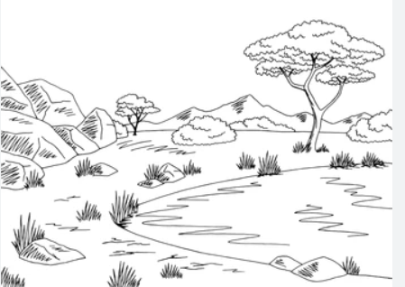

A group of lions that live together

**savvanah**

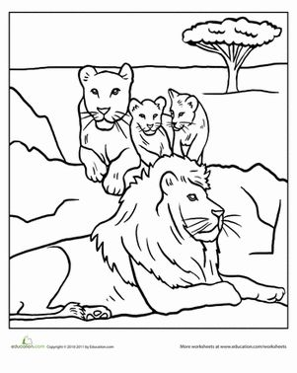

A group of gorillas living together

**pride**

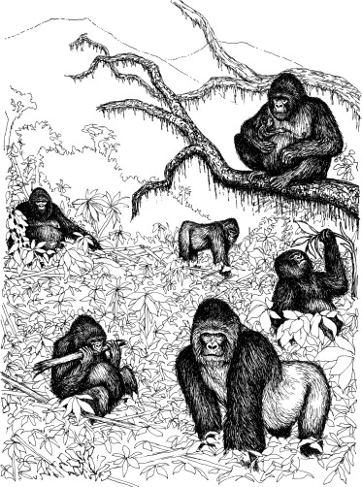

A large area of land covered with grass.

**troop**