

English

Weekly Pack

Year 2-Week 12



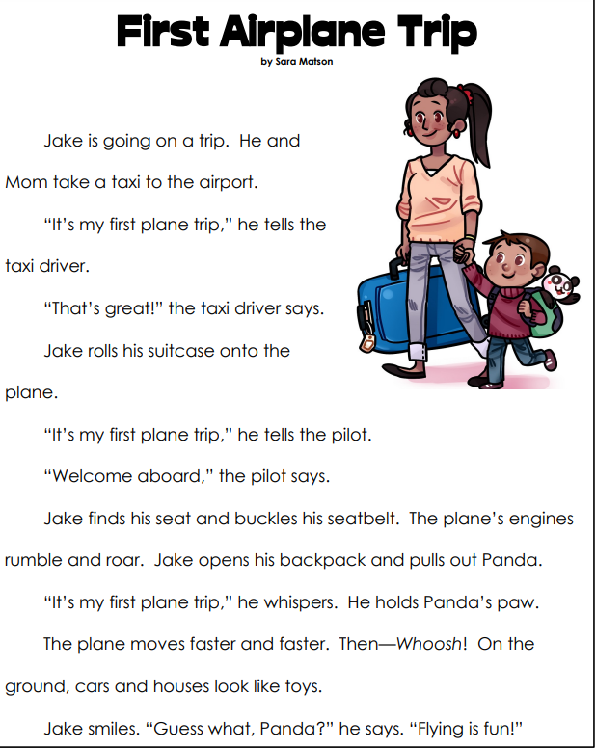

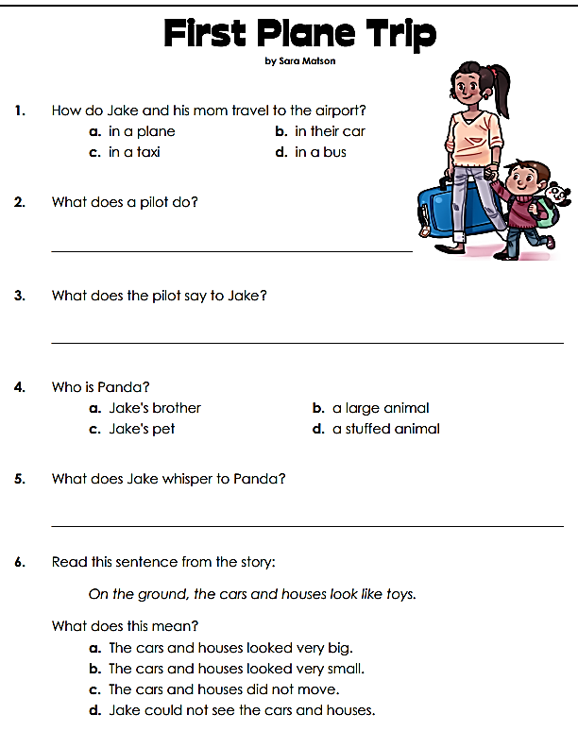

7**.Read the text and find:**

-A verb in present tense:

_________________

-A synonym for the word “estimate”

-An antonym for “close”

__________________

-A noun

_____________

-A verb

-An adjective

____________________

